Chapter 5 Propositions

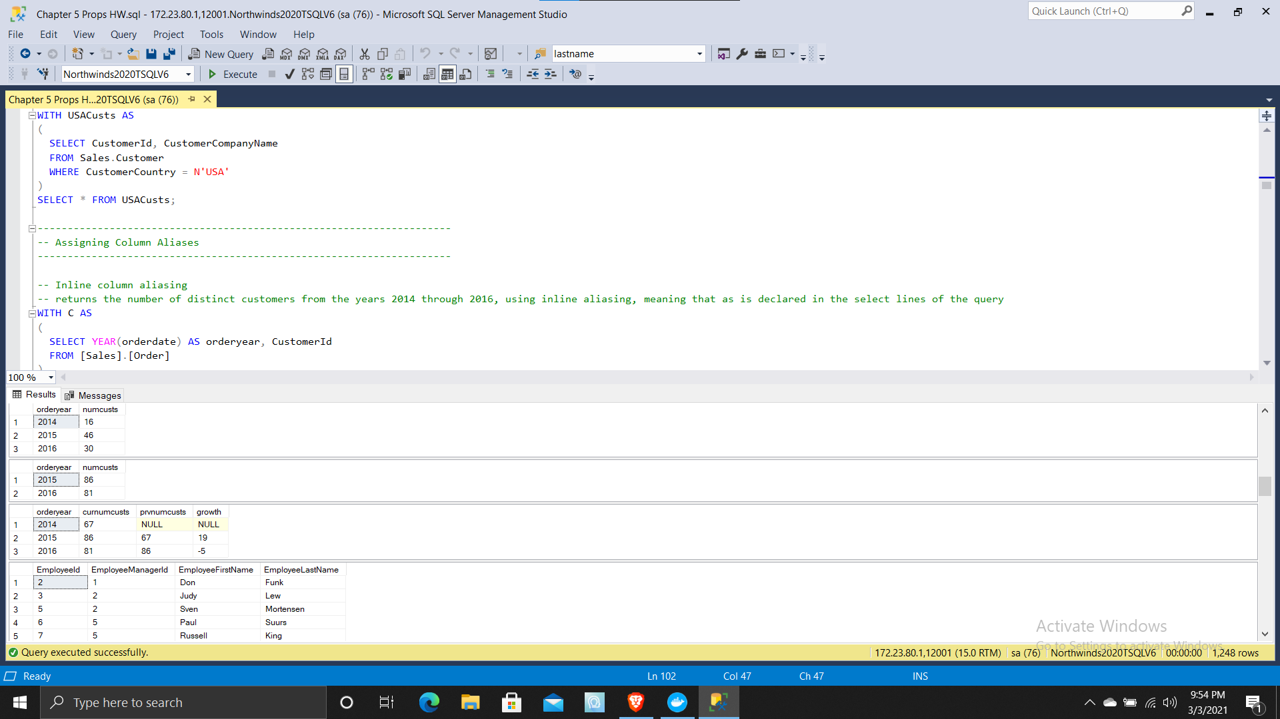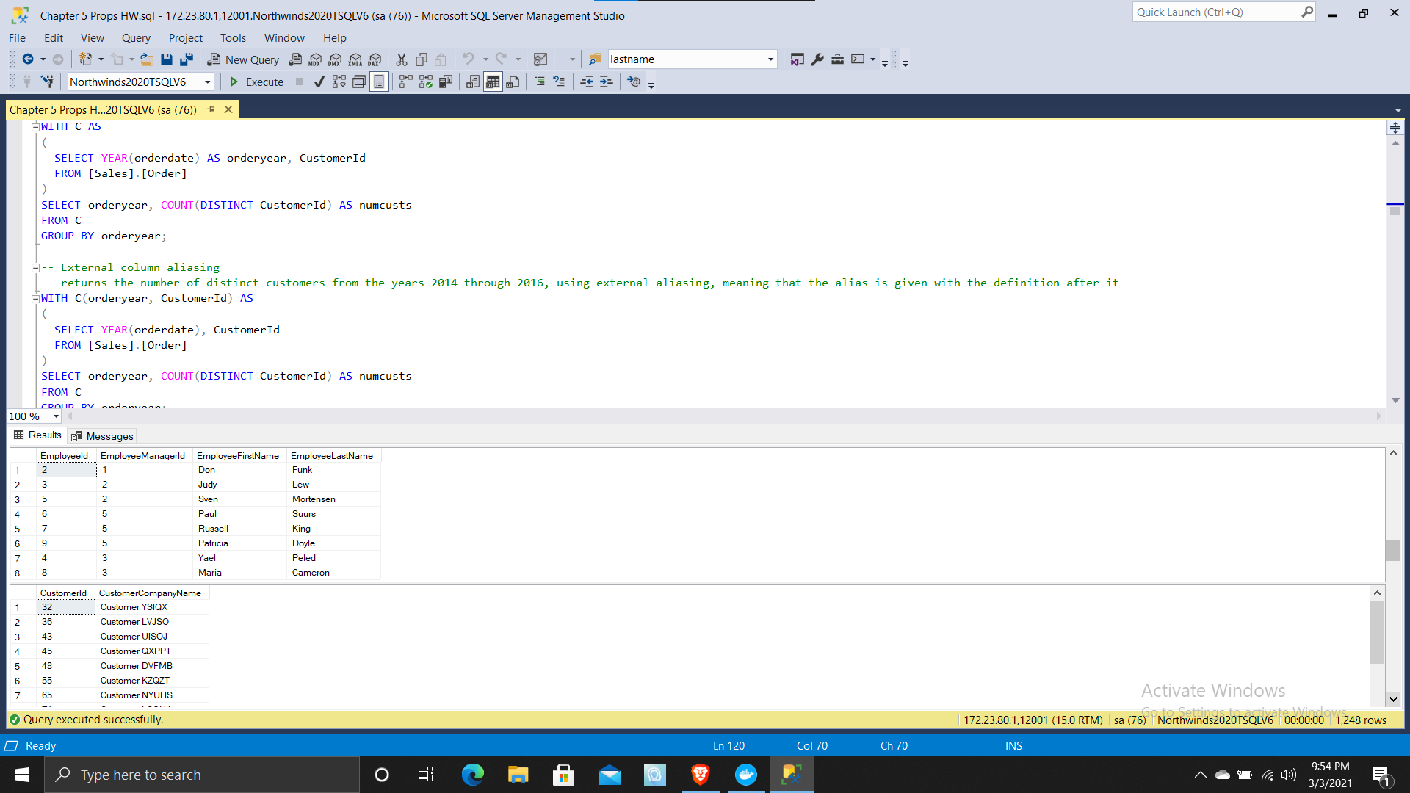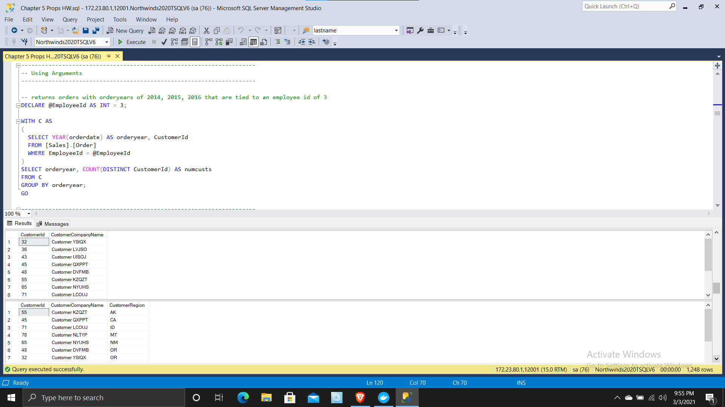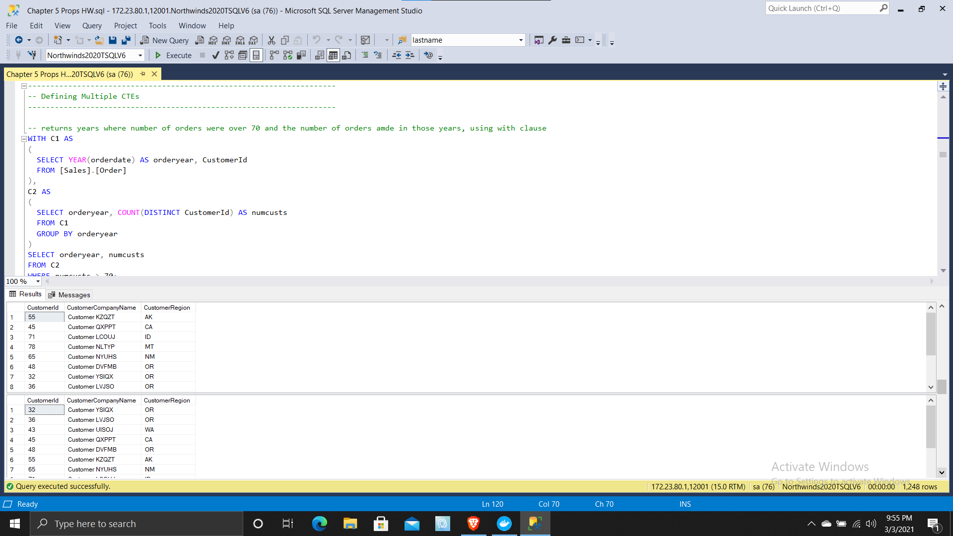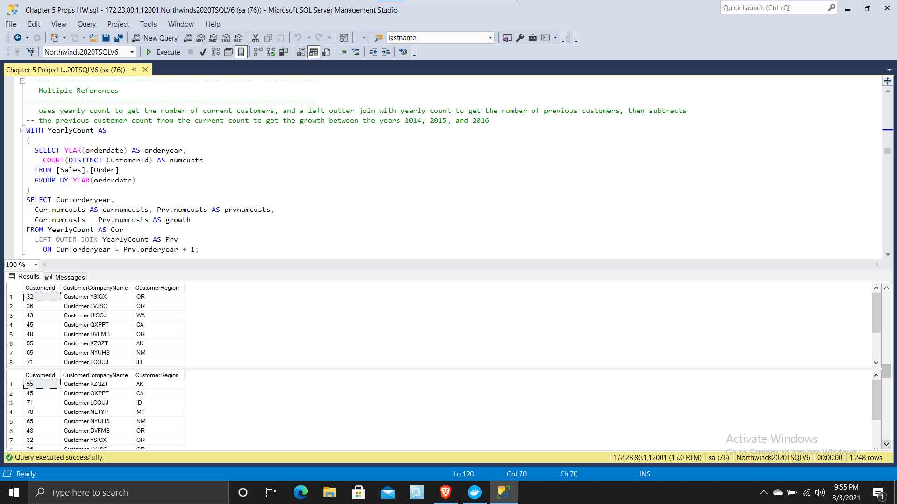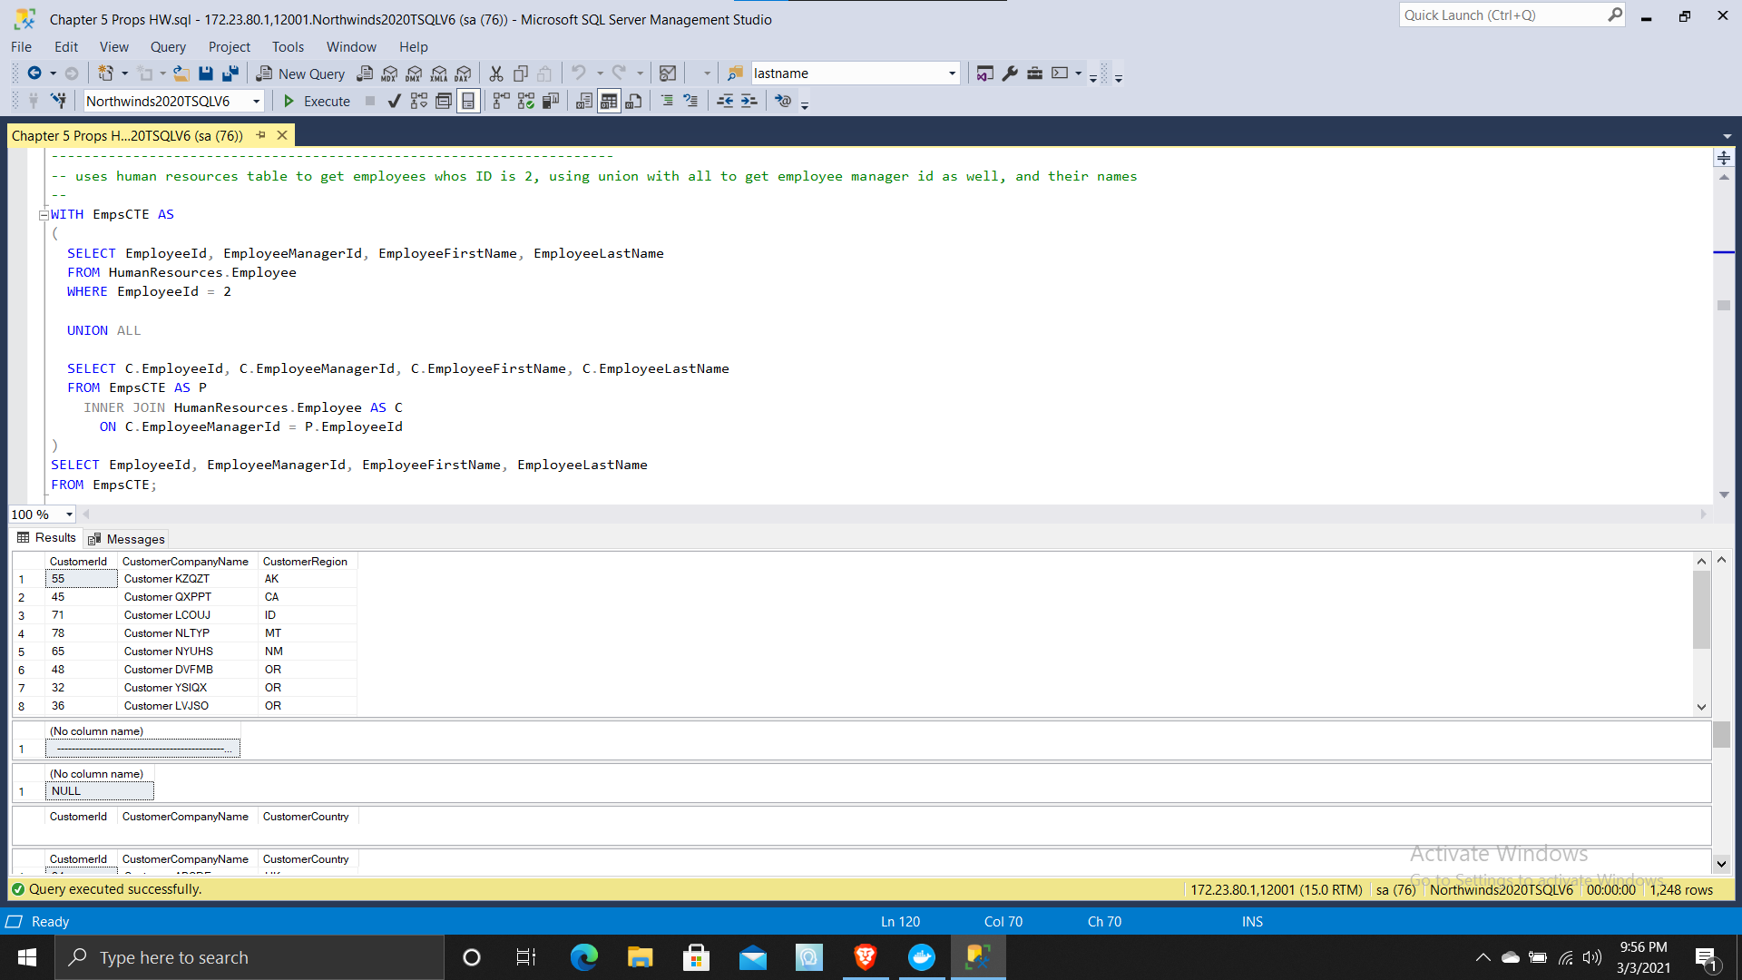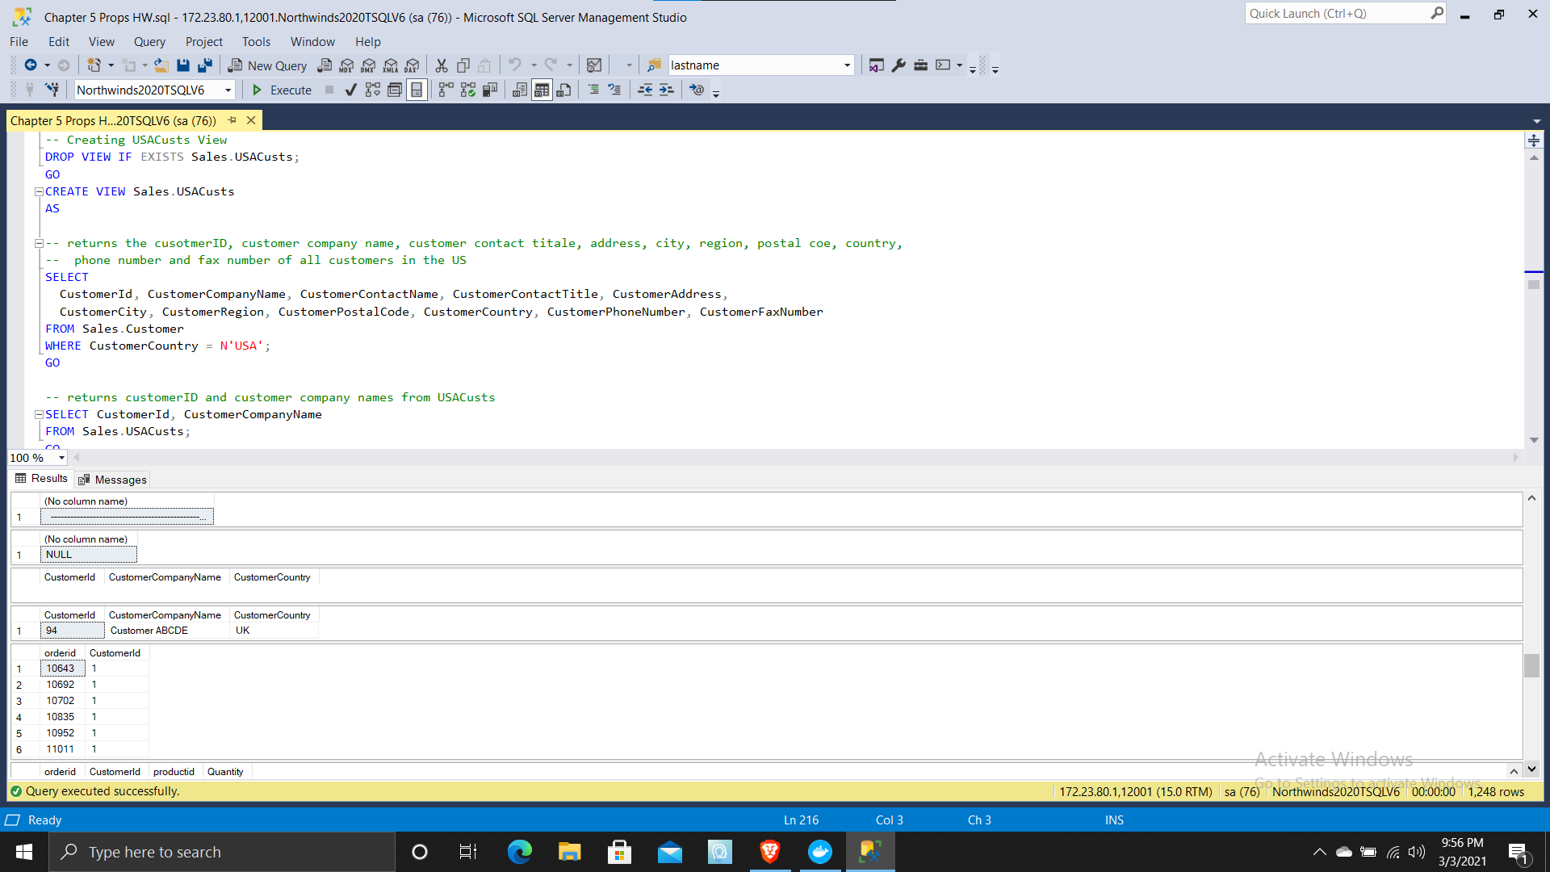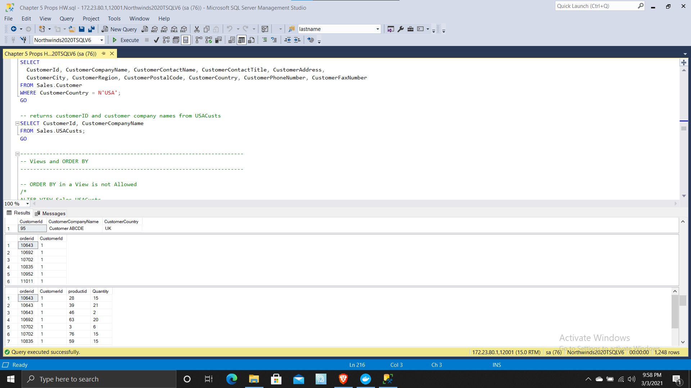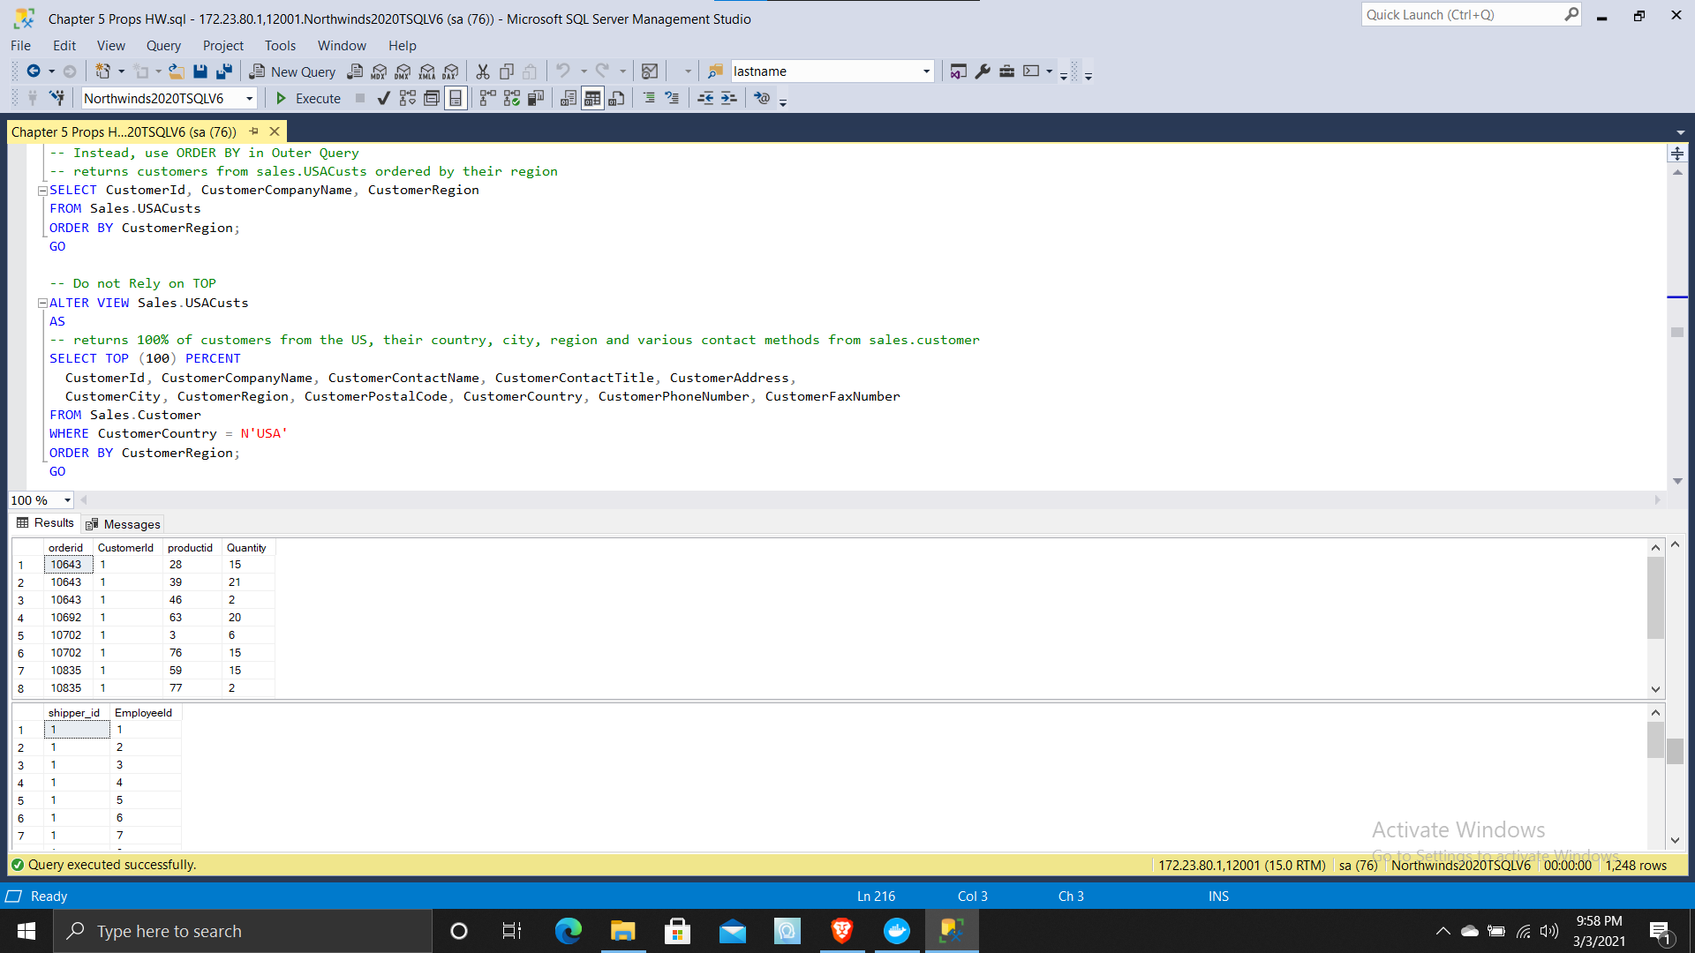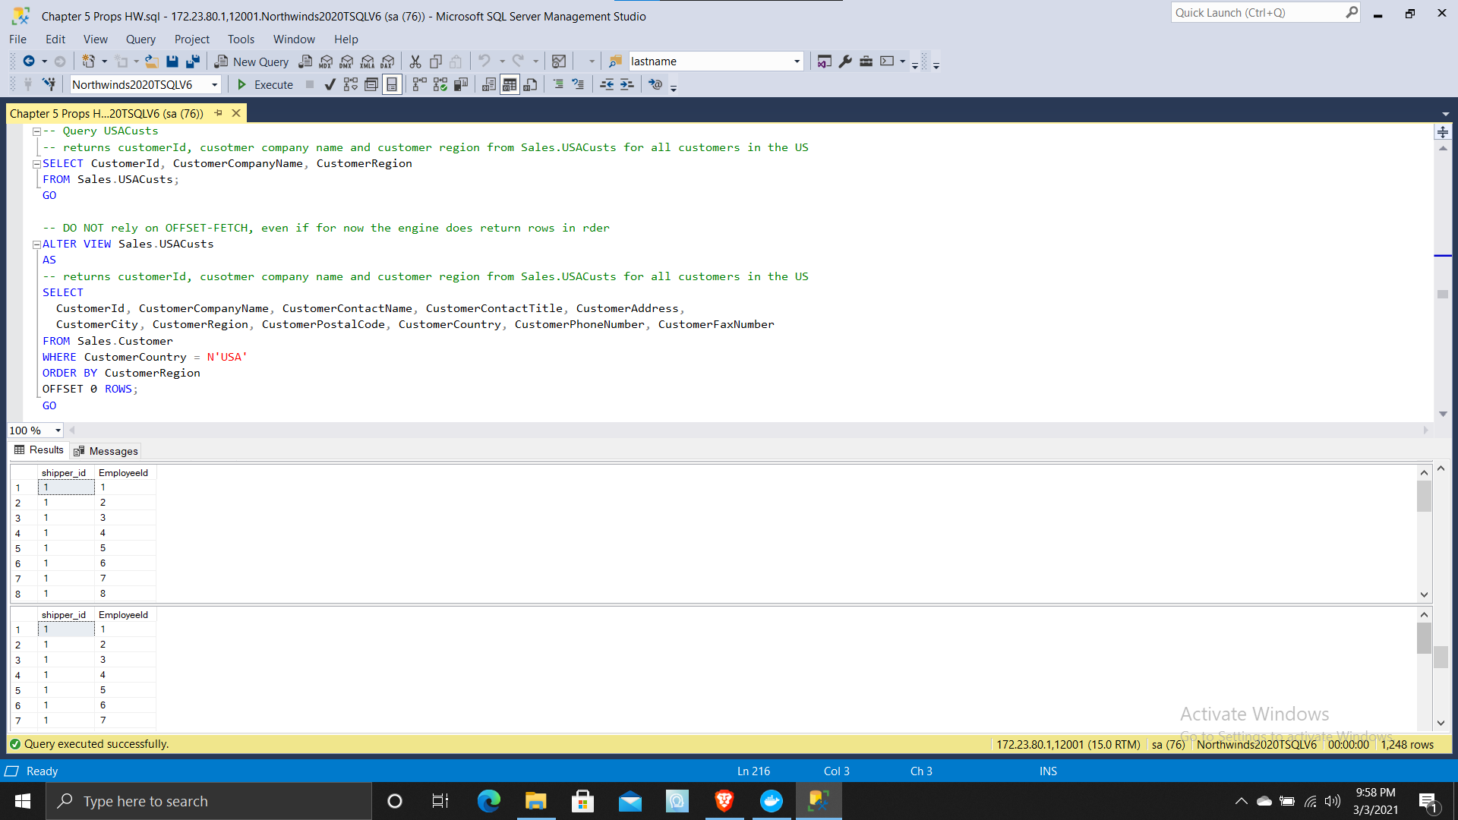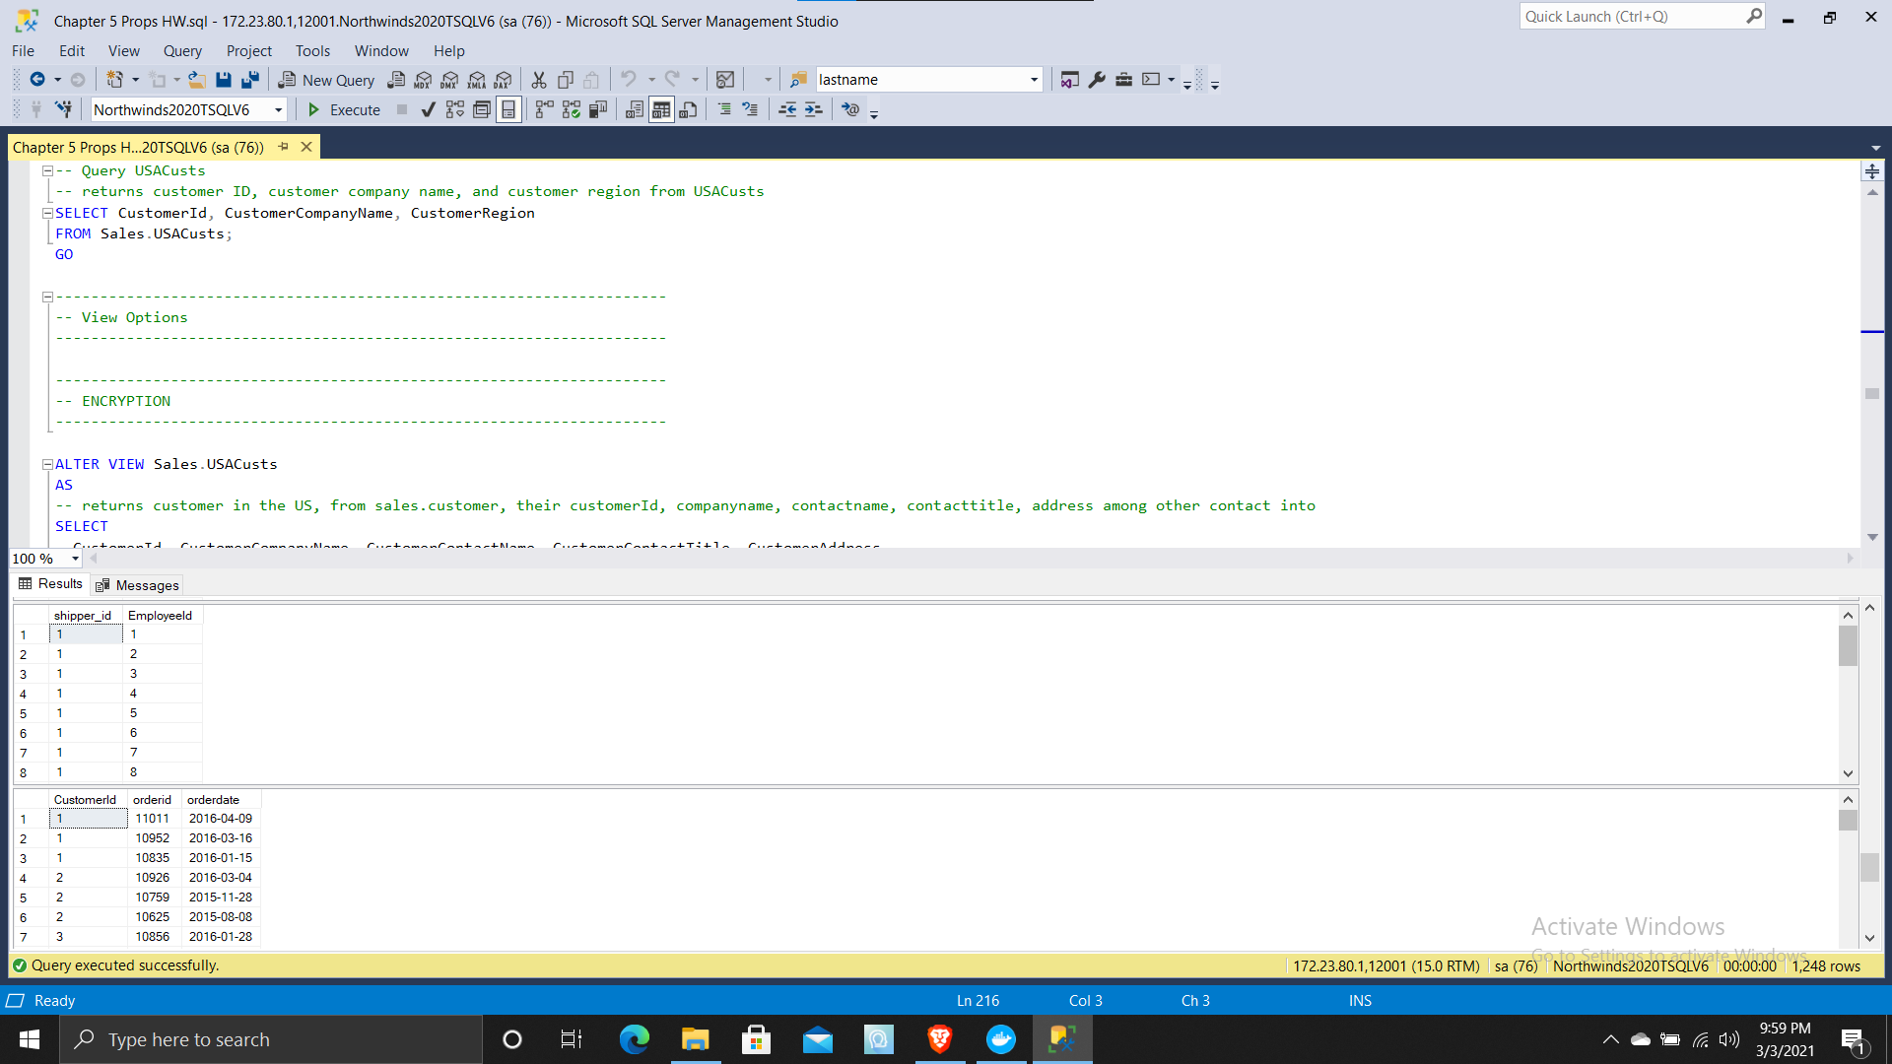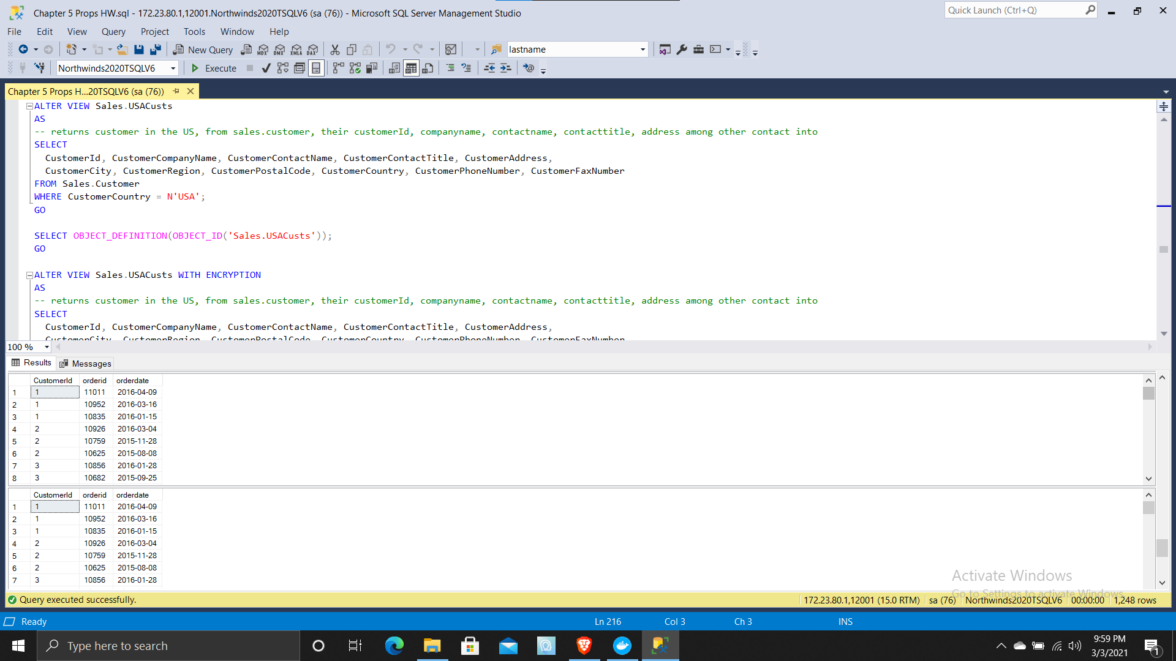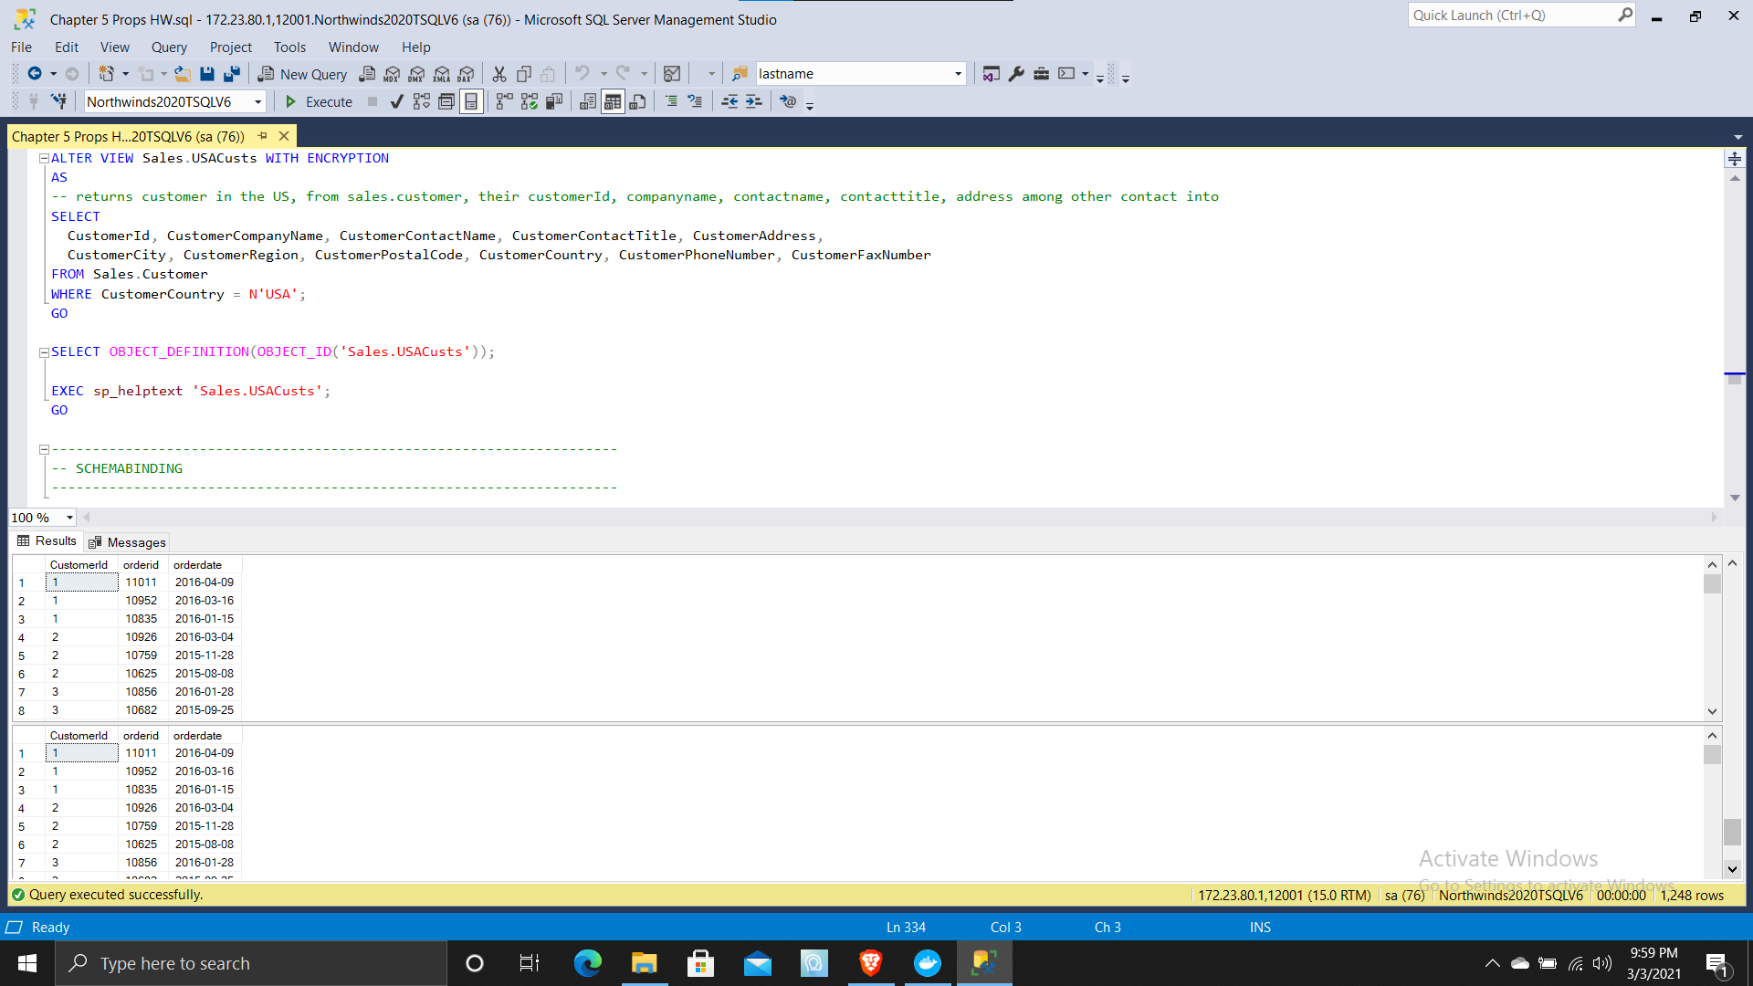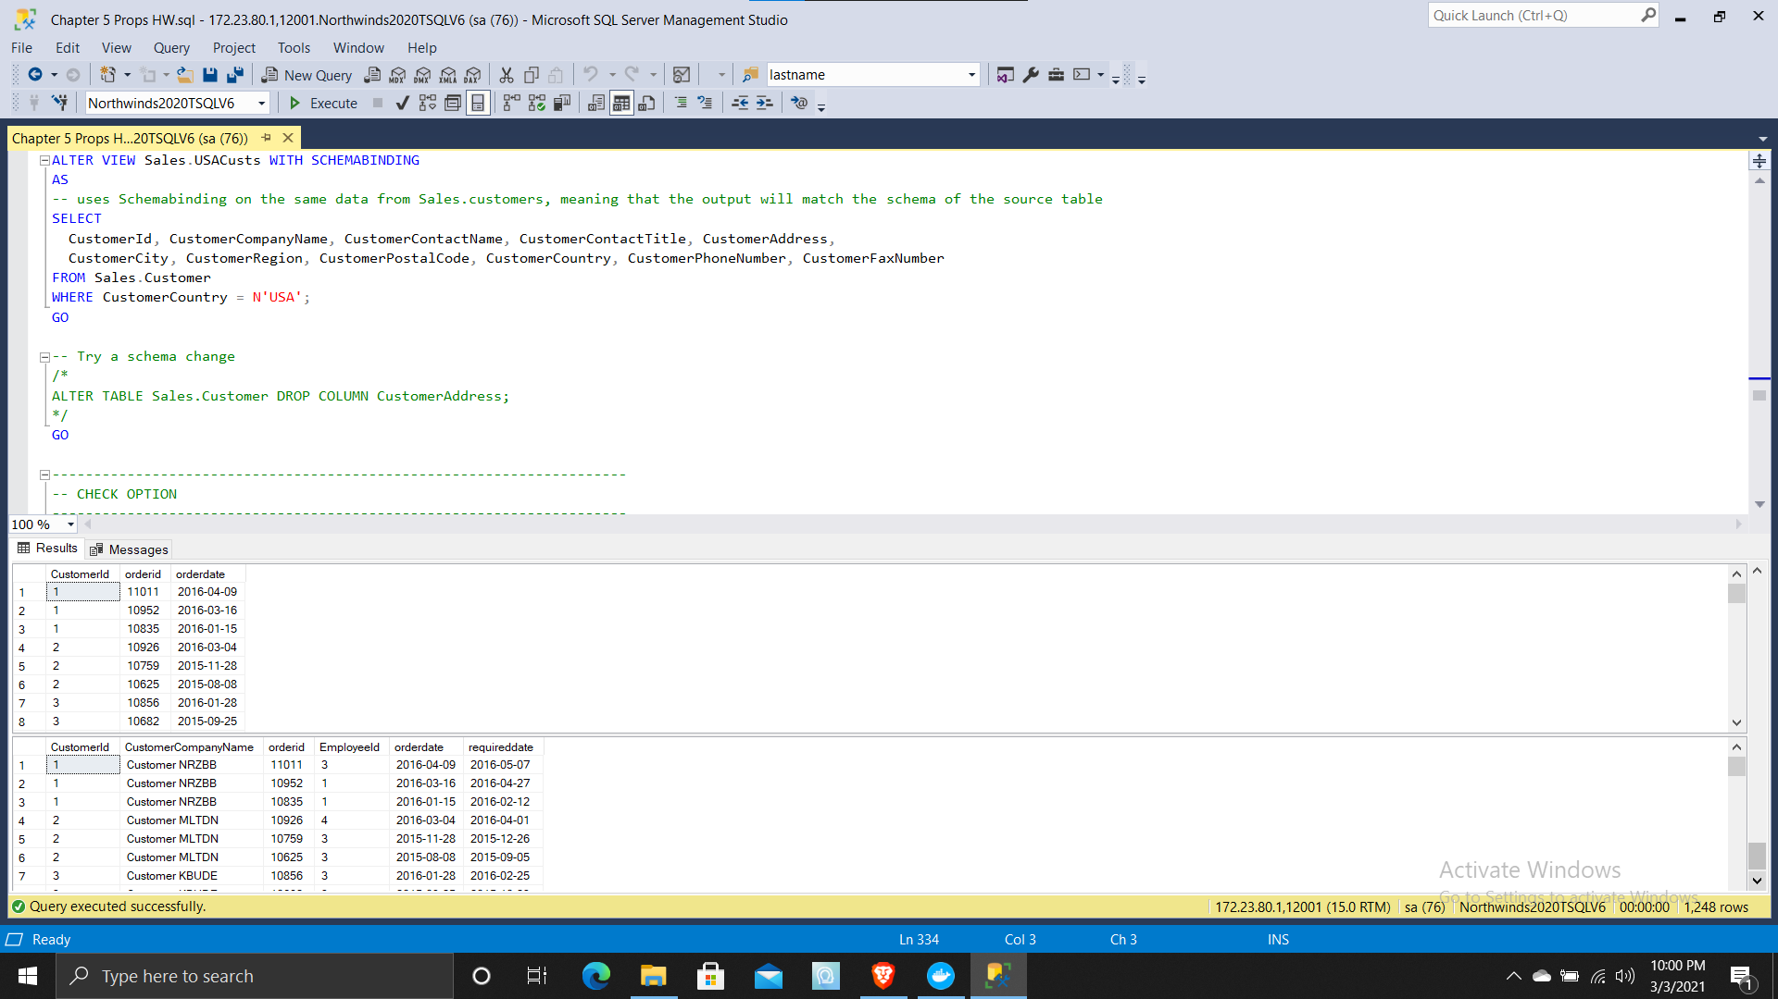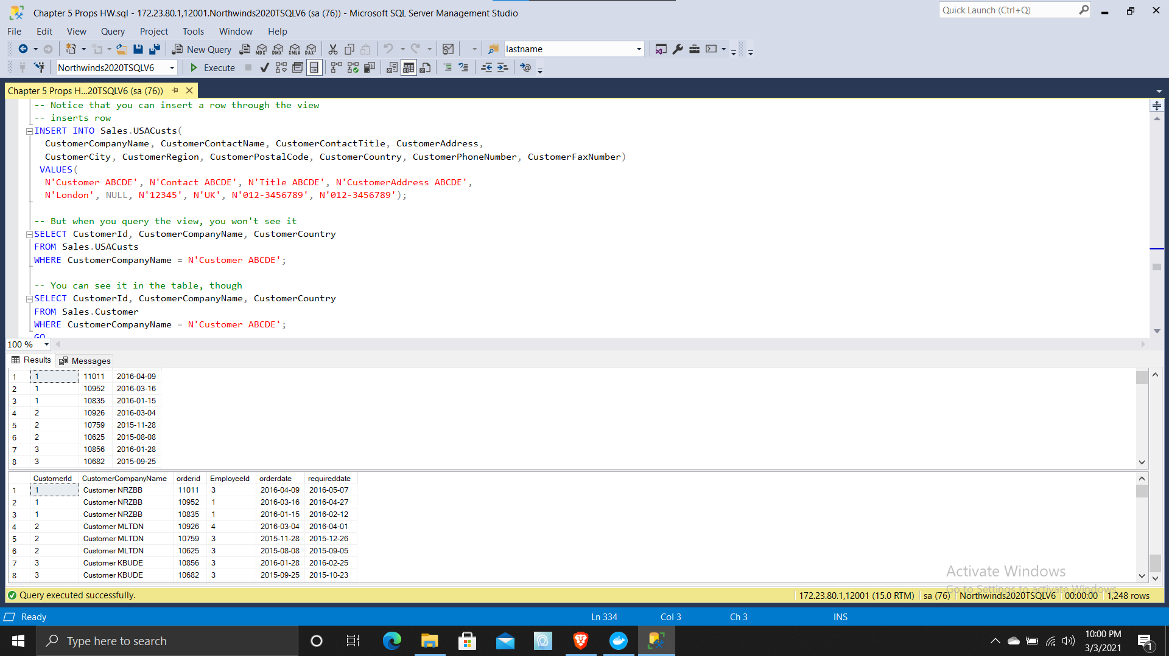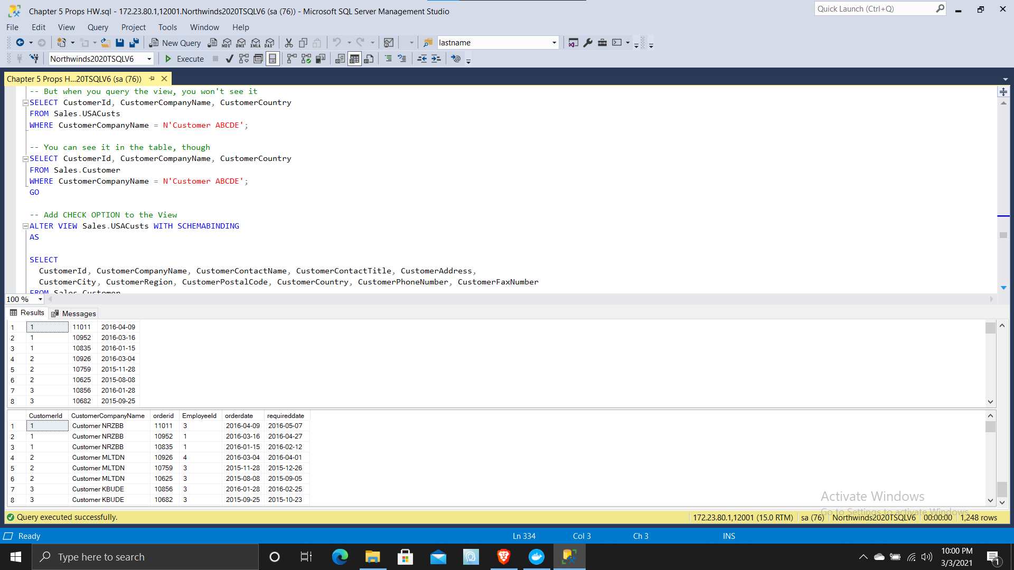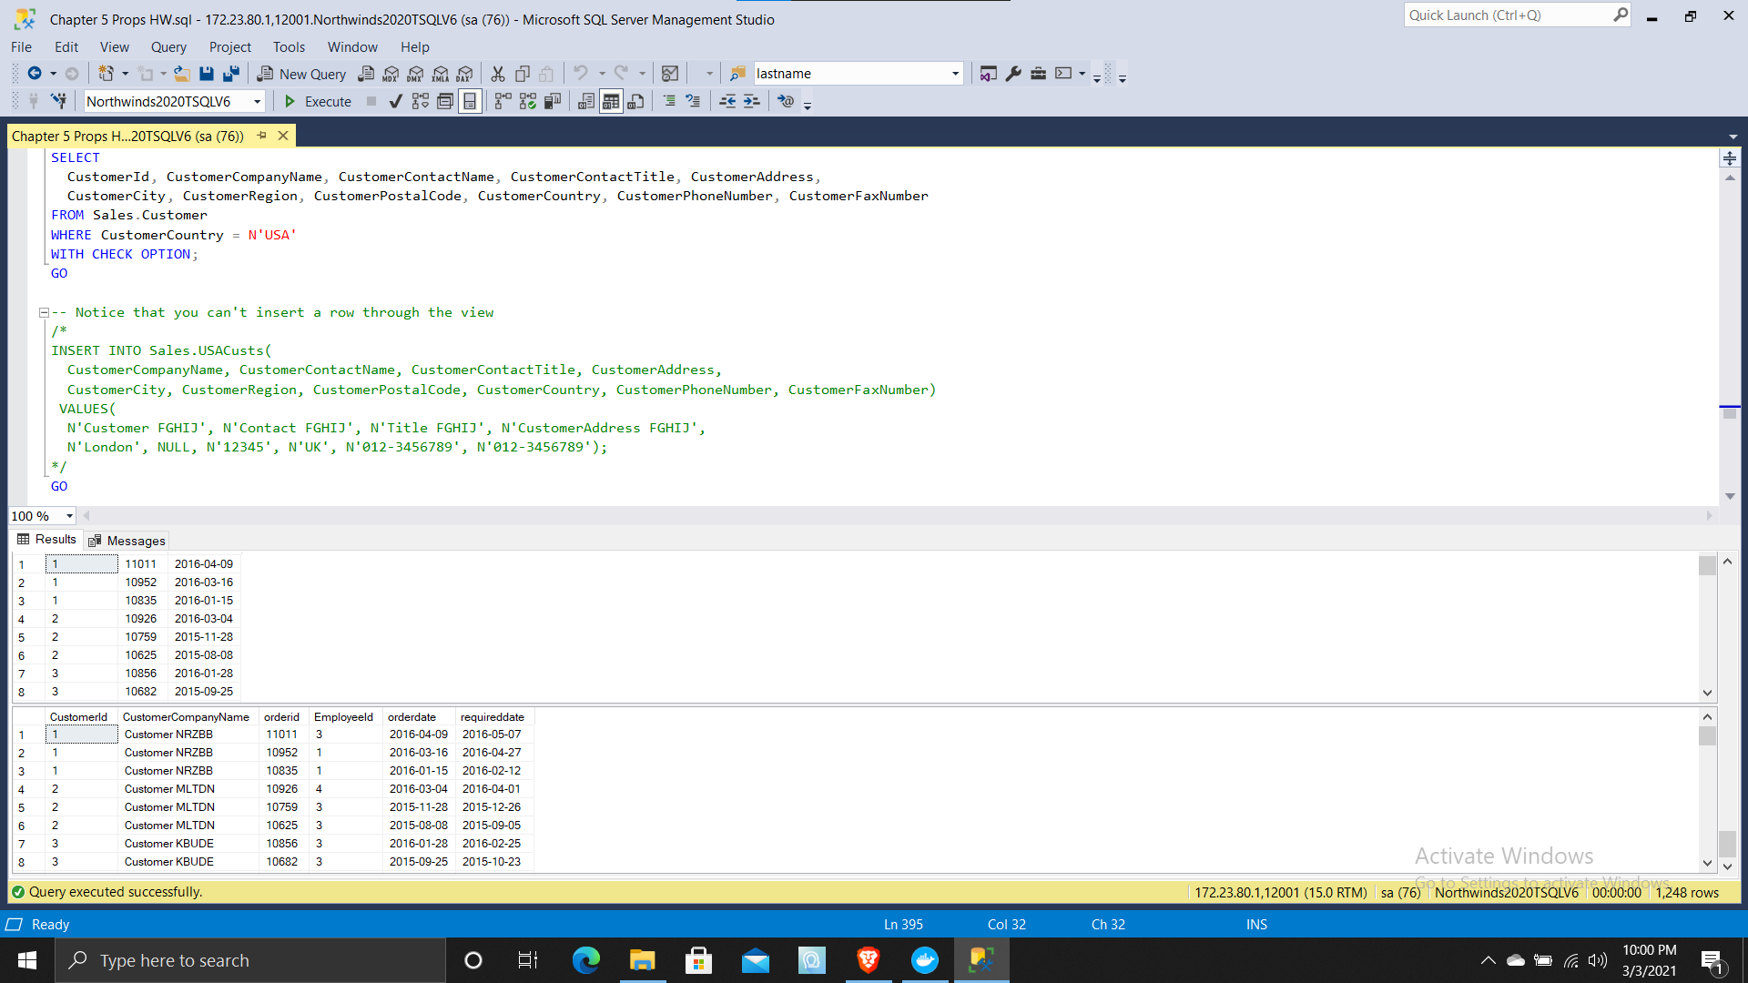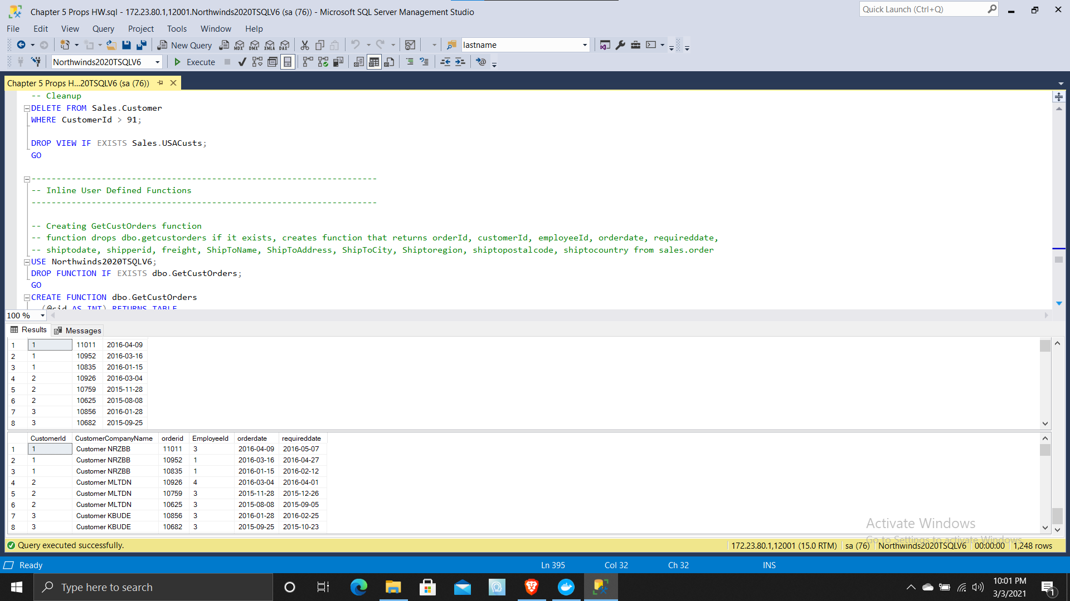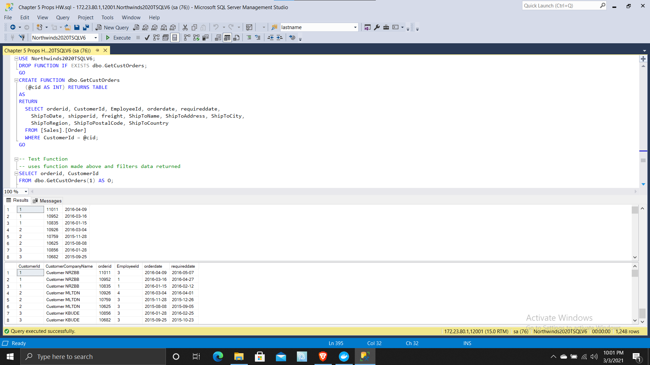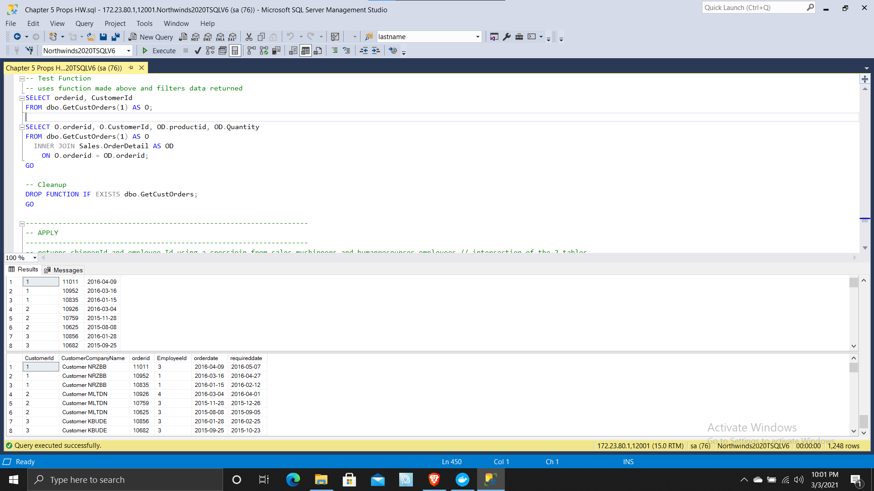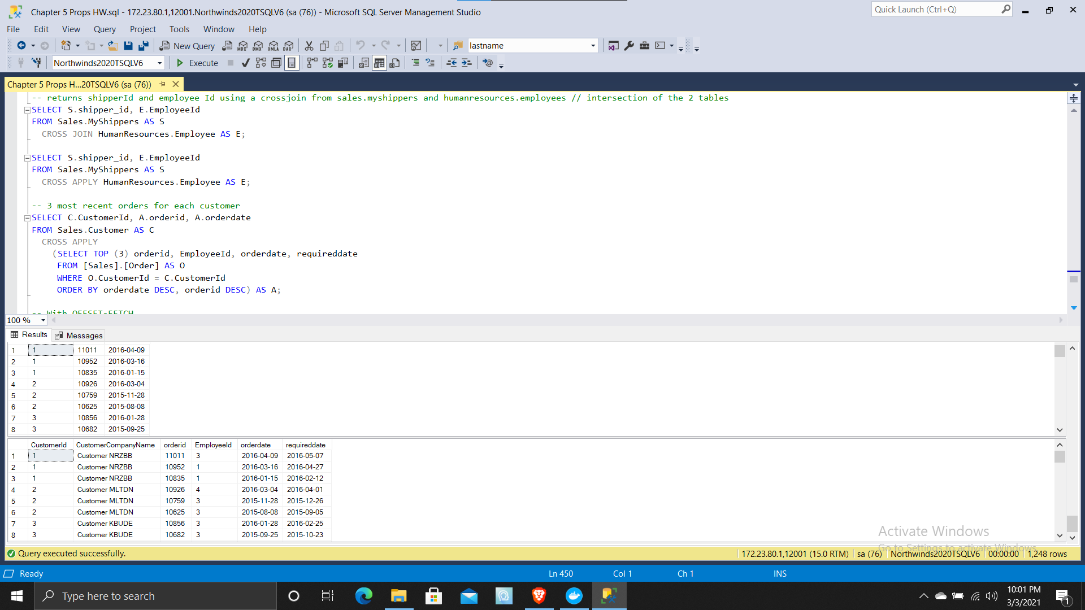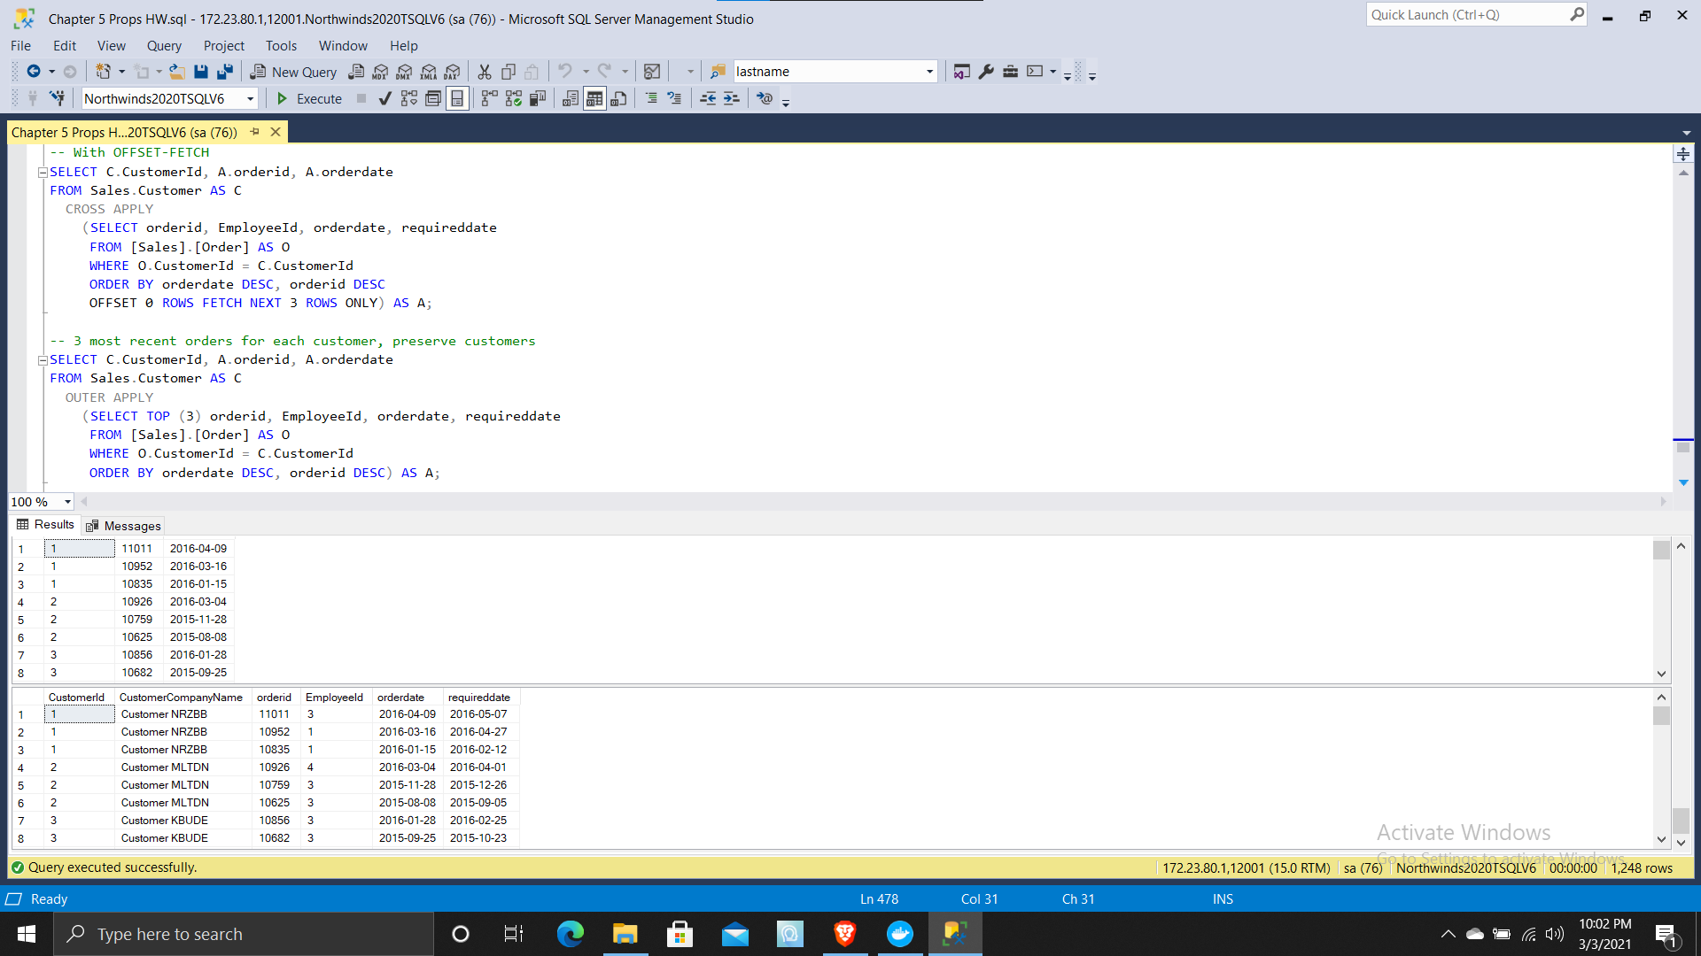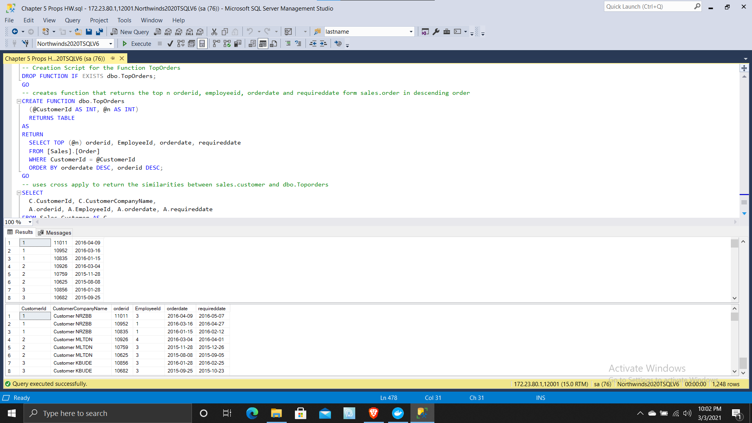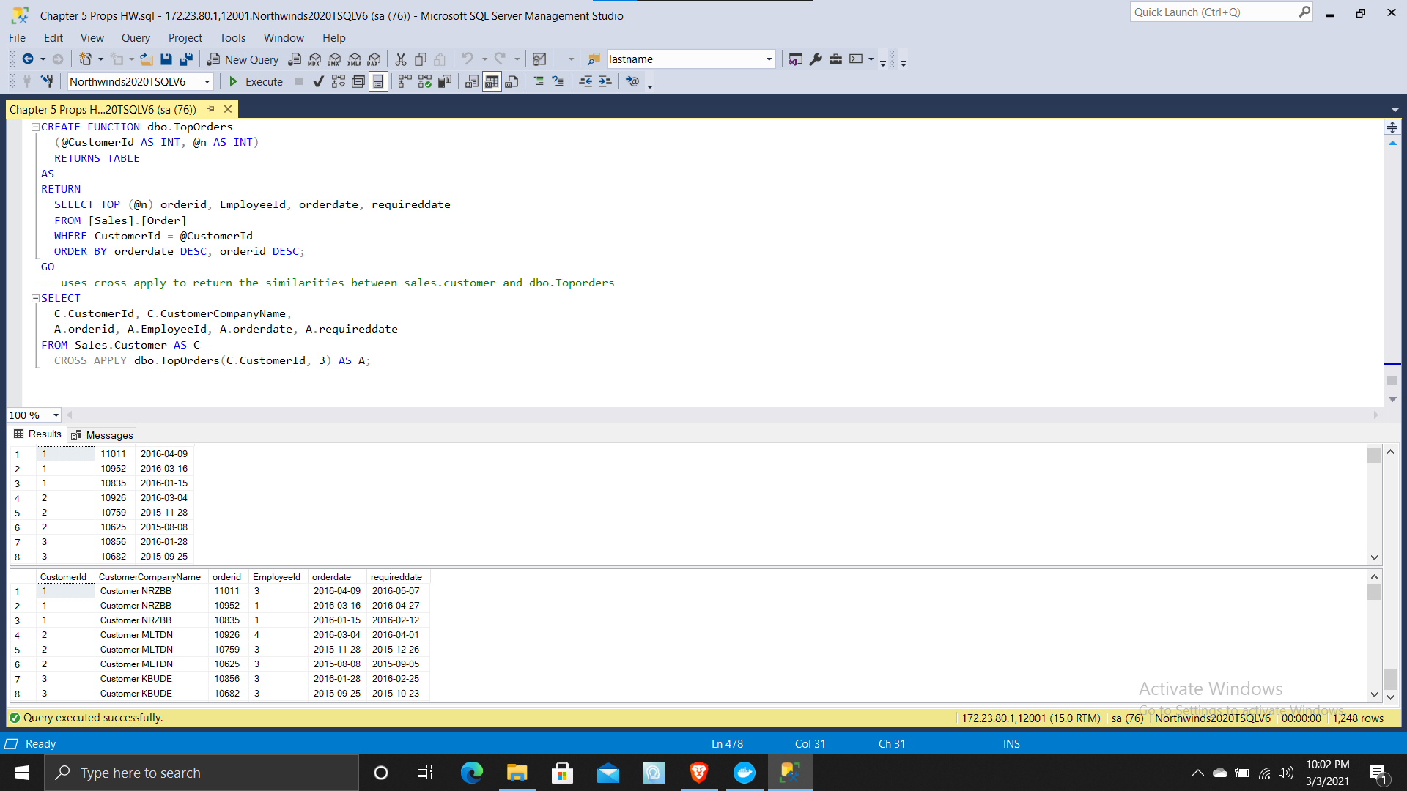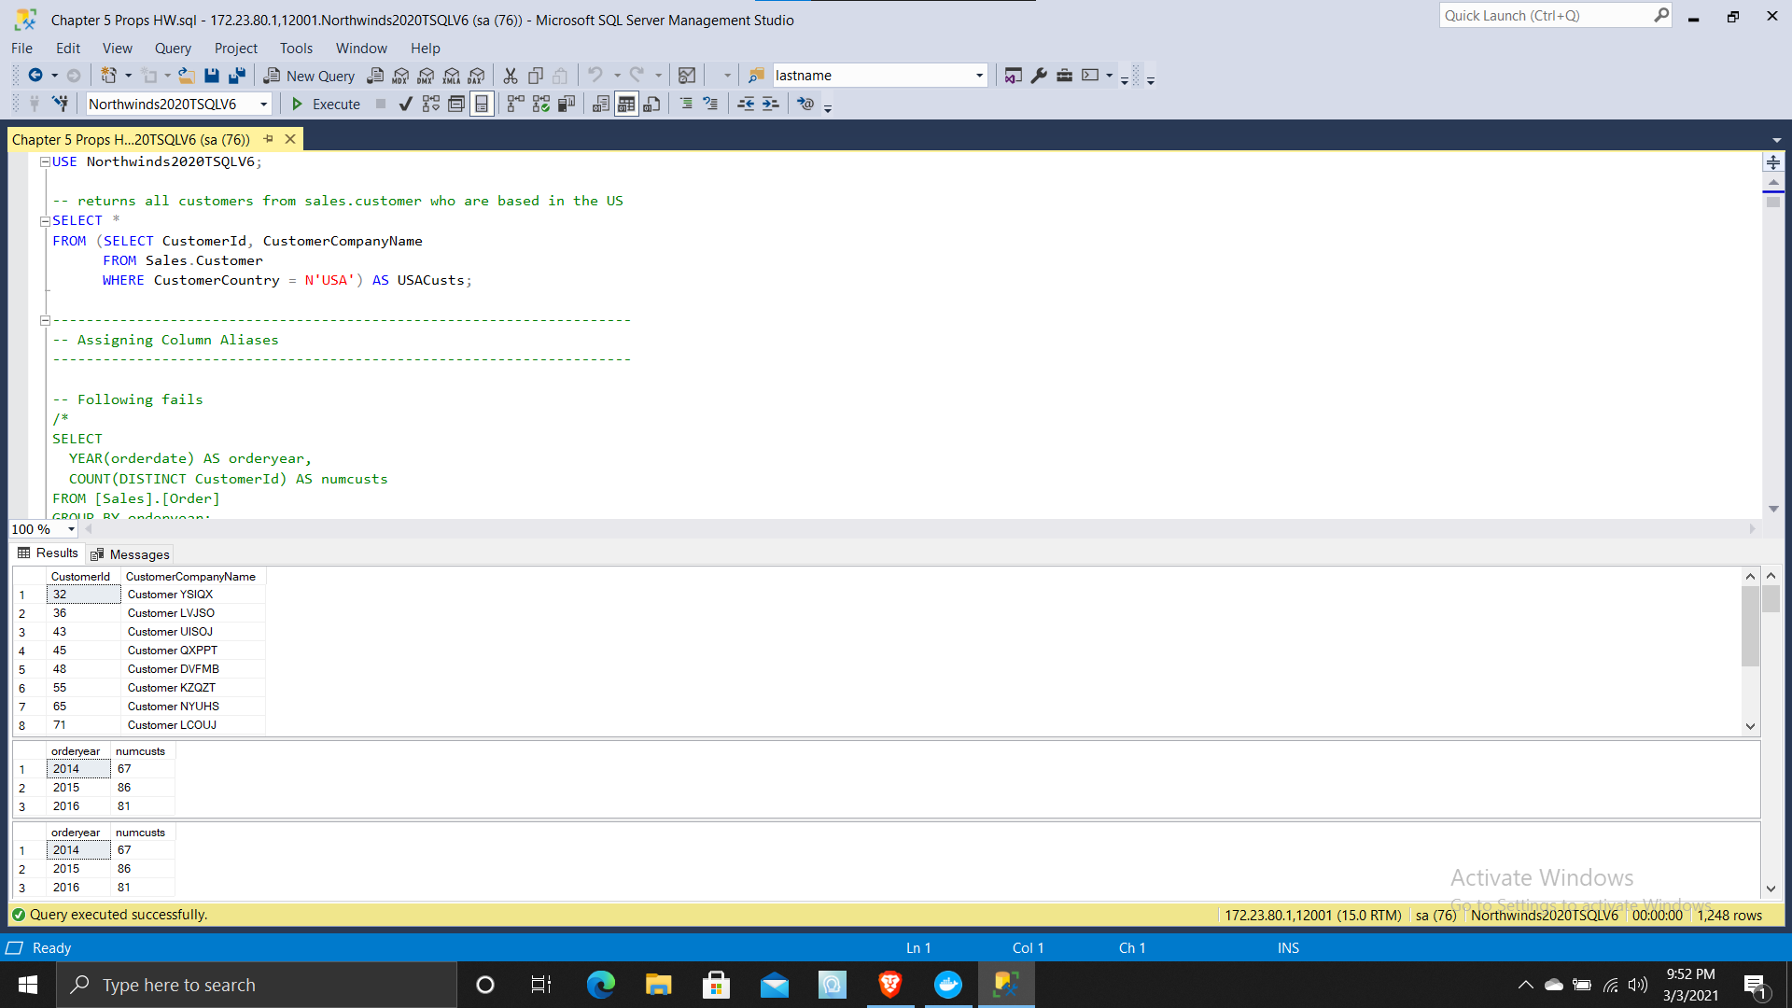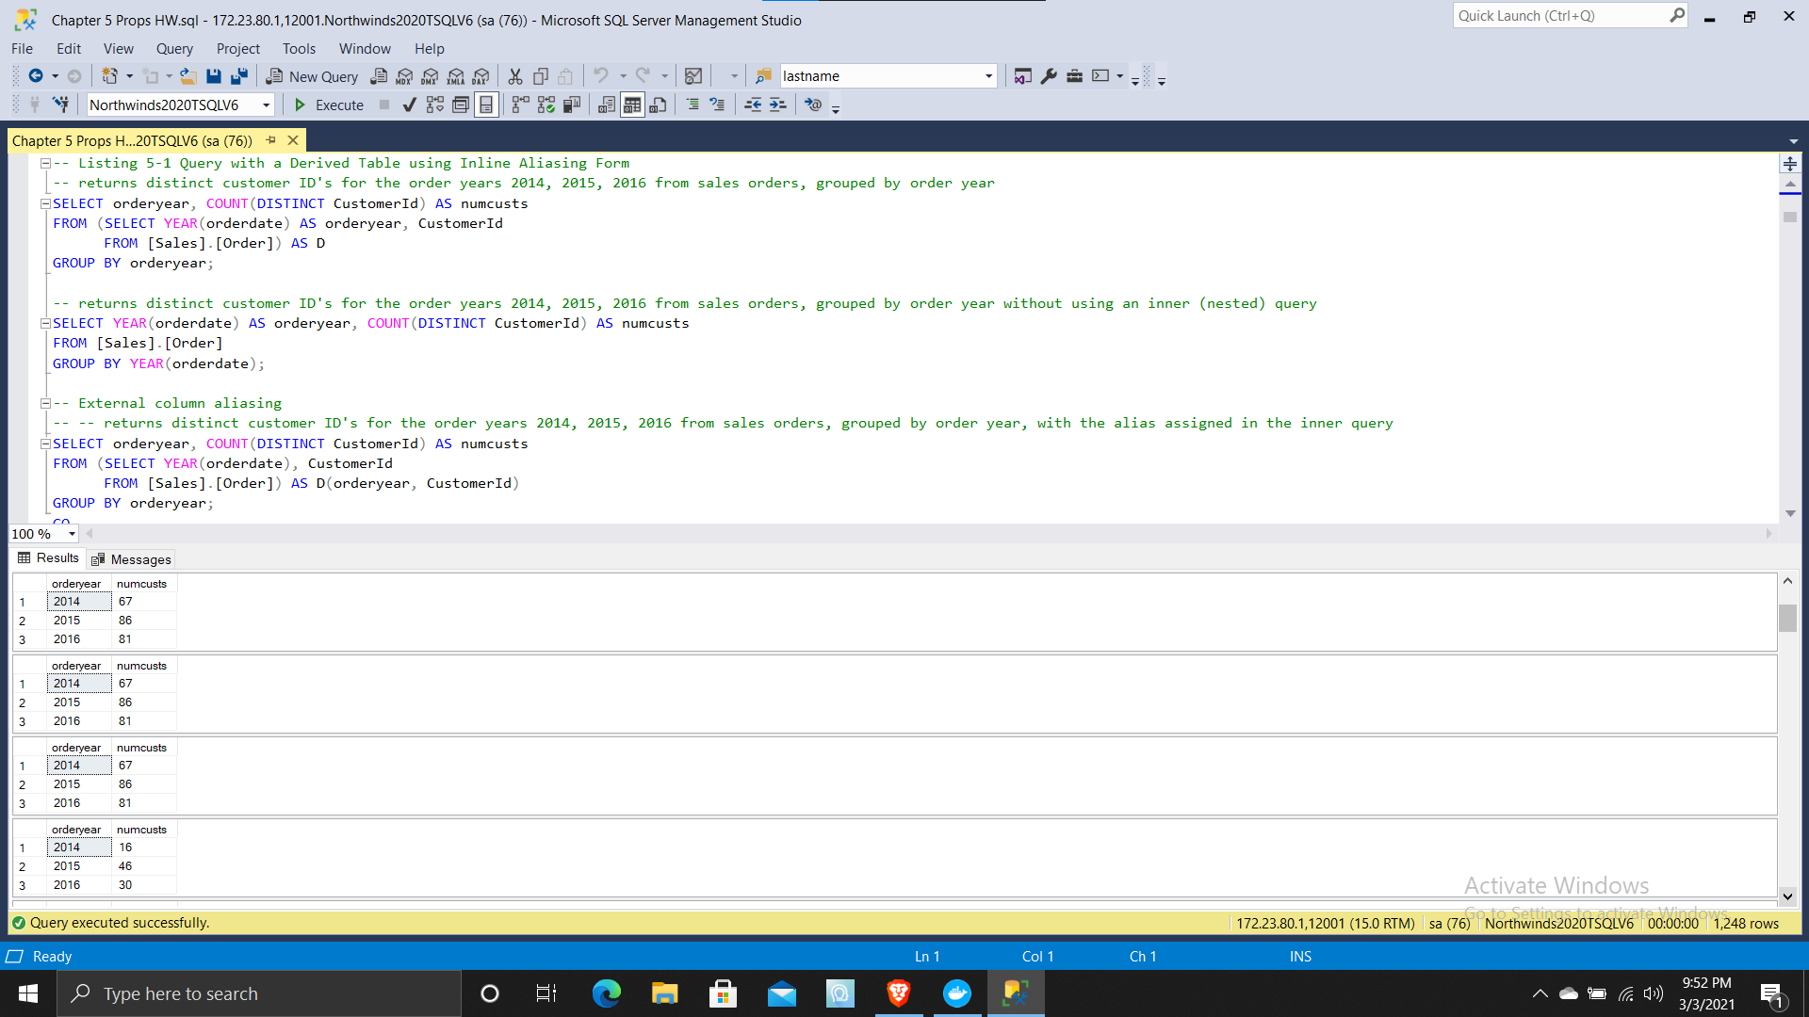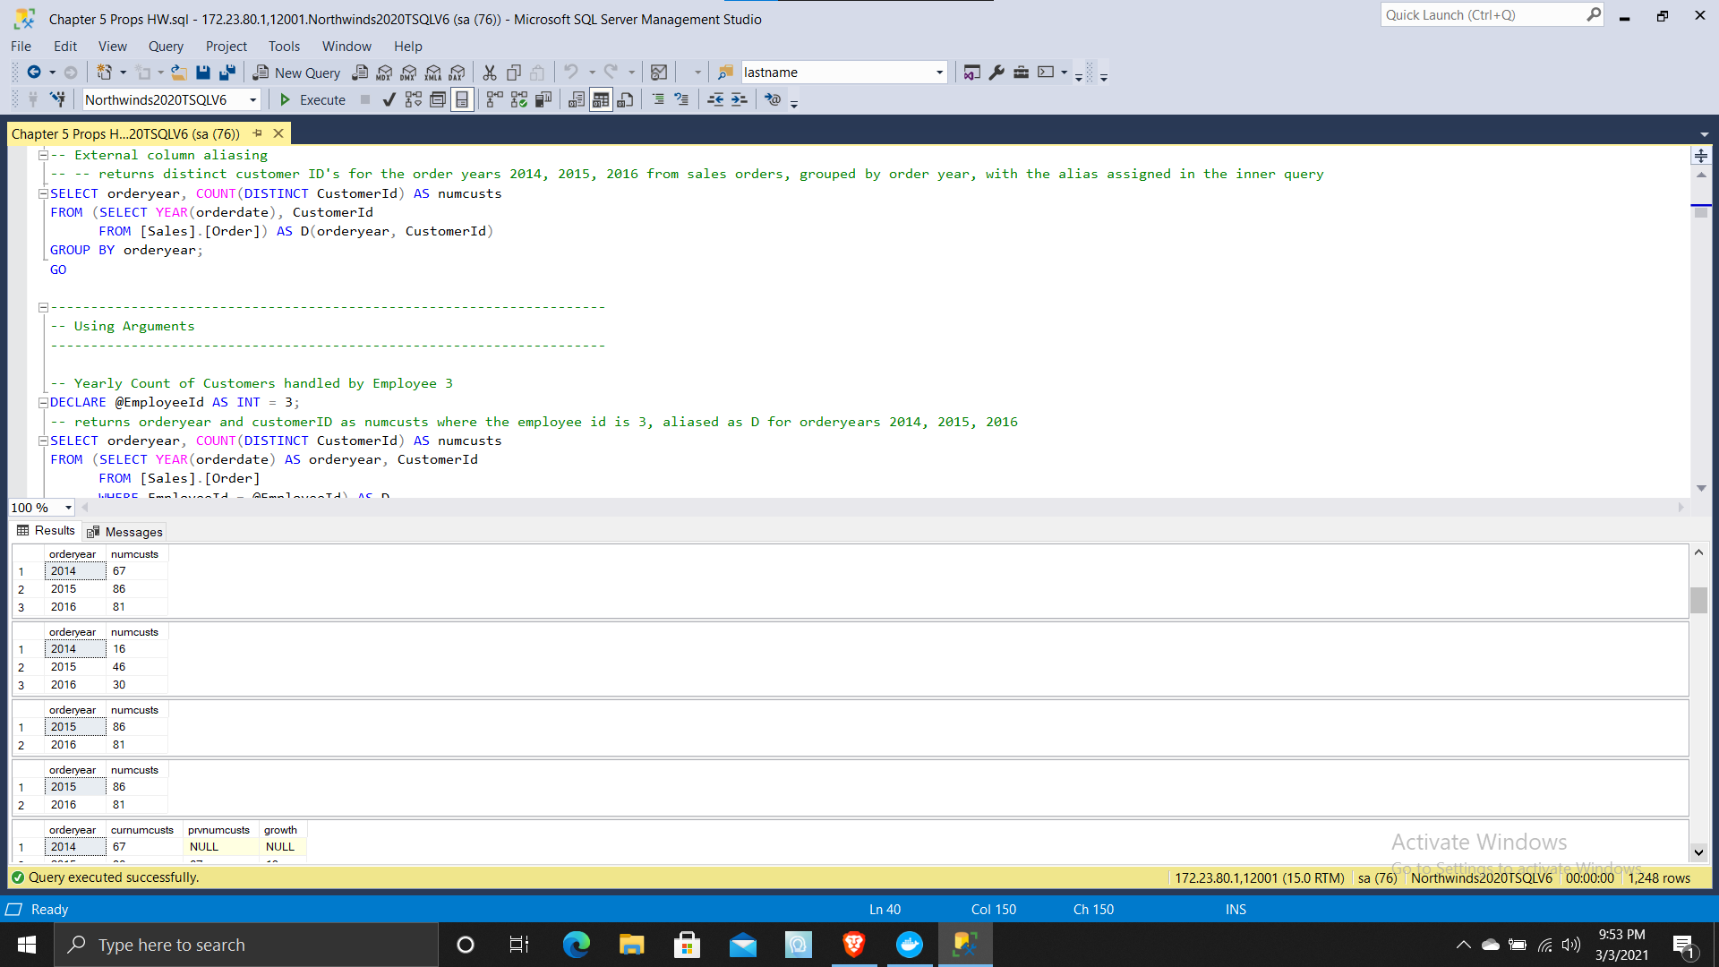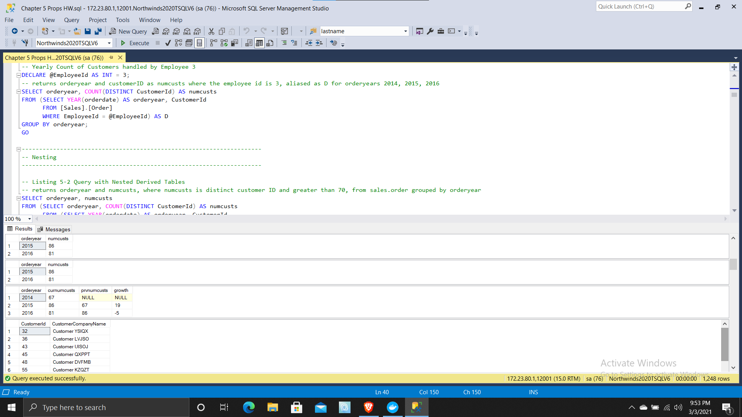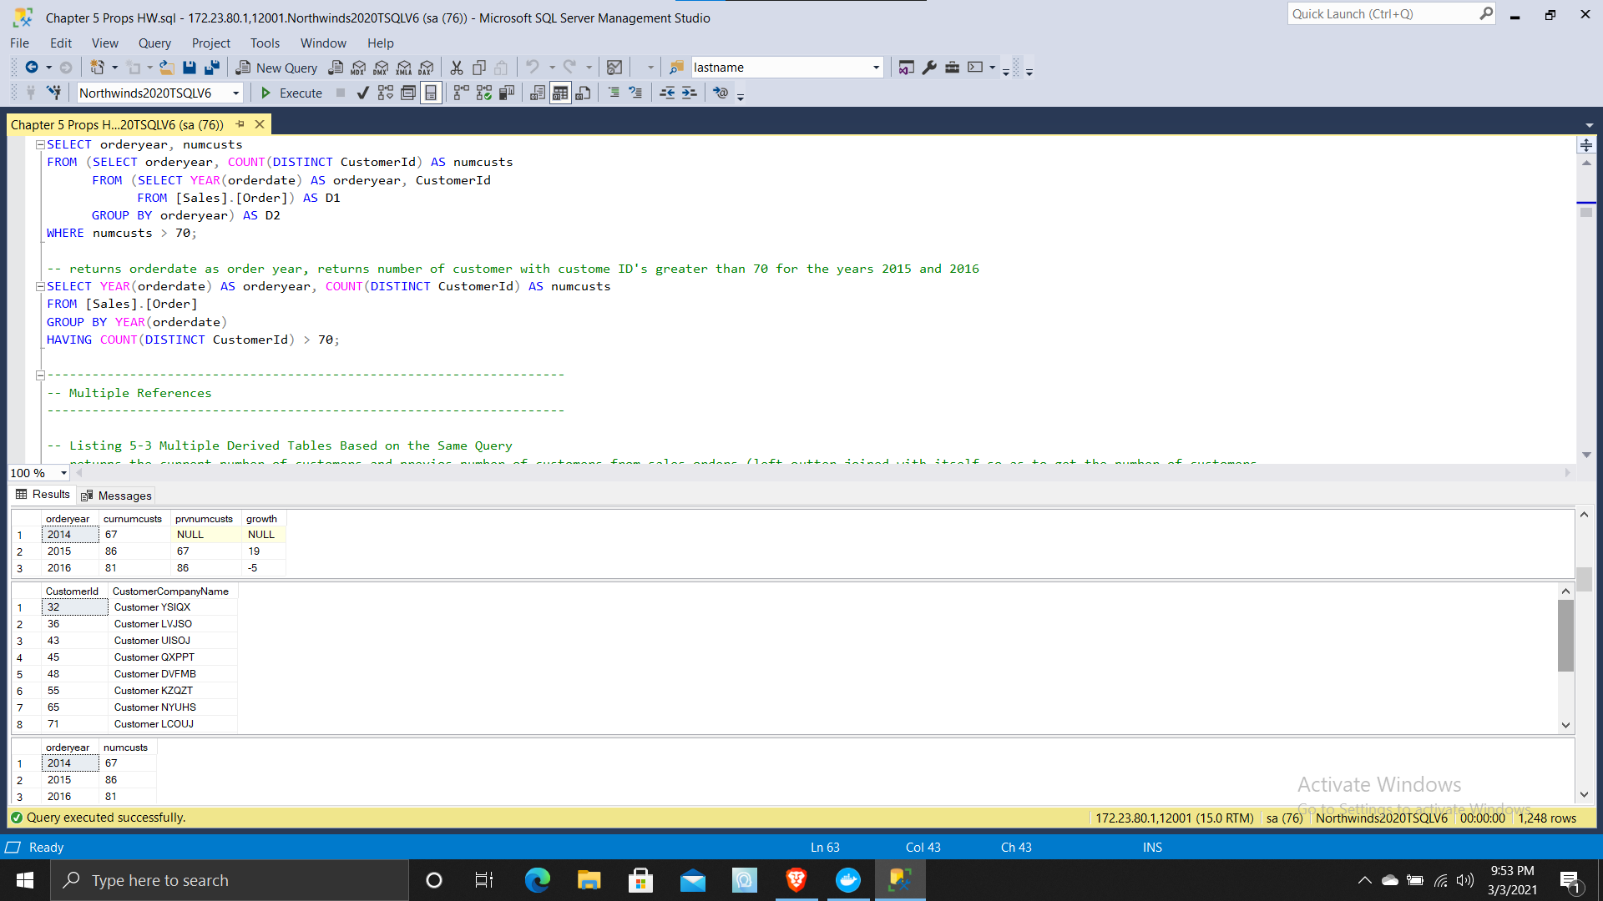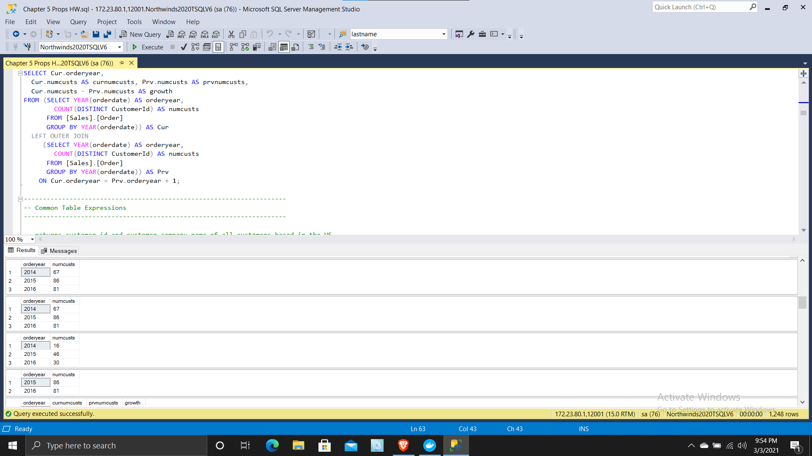

(13 rows affected)

Warning: Null value is eliminated by an aggregate or other SET operation.

(3 rows affected)

Warning: Null value is eliminated by an aggregate or other SET operation.

(3 rows affected)

Warning: Null value is eliminated by an aggregate or other SET operation.

(3 rows affected)

(3 rows affected)

Warning: Null value is eliminated by an aggregate or other SET operation.

(2 rows affected)

Warning: Null value is eliminated by an aggregate or other SET operation.

(2 rows affected)

Warning: Null value is eliminated by an aggregate or other SET operation.

(3 rows affected)

(13 rows affected)

Warning: Null value is eliminated by an aggregate or other SET operation.

(3 rows affected)

Warning: Null value is eliminated by an aggregate or other SET operation.

(3 rows affected)

(3 rows affected)

Warning: Null value is eliminated by an aggregate or other SET operation.

(2 rows affected)

Warning: Null value is eliminated by an aggregate or other SET operation.

(3 rows affected)

(8 rows affected)

(13 rows affected)

(13 rows affected)

(13 rows affected)

(13 rows affected)

(1 row affected)

(1 row affected)

The text for object 'Sales.USACusts' is encrypted.

(1 row affected)

(0 rows affected)

(1 row affected)

(1 row affected)

(6 rows affected)

(12 rows affected)

(27 rows affected)

(27 rows affected)

(263 rows affected)

(263 rows affected)

(265 rows affected)

(263 rows affected)

Completion time: 2021-03-03T21:57:13.6300612-05:00

Chapter 5 Exercises

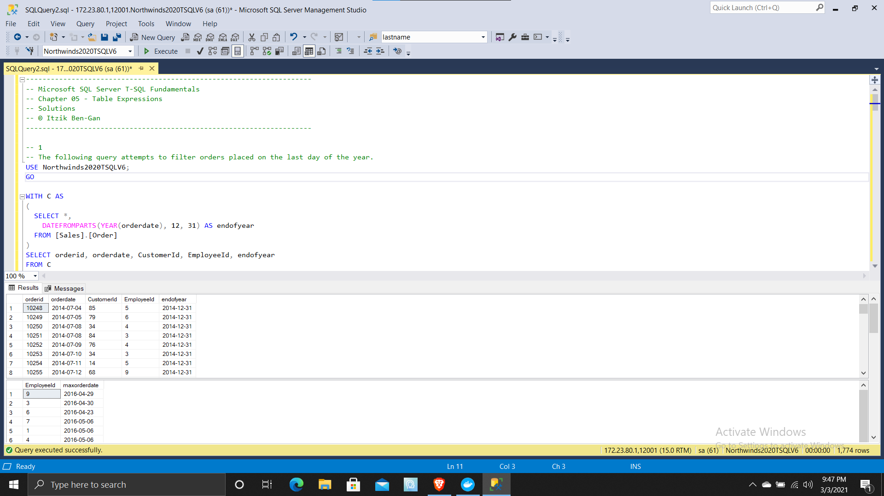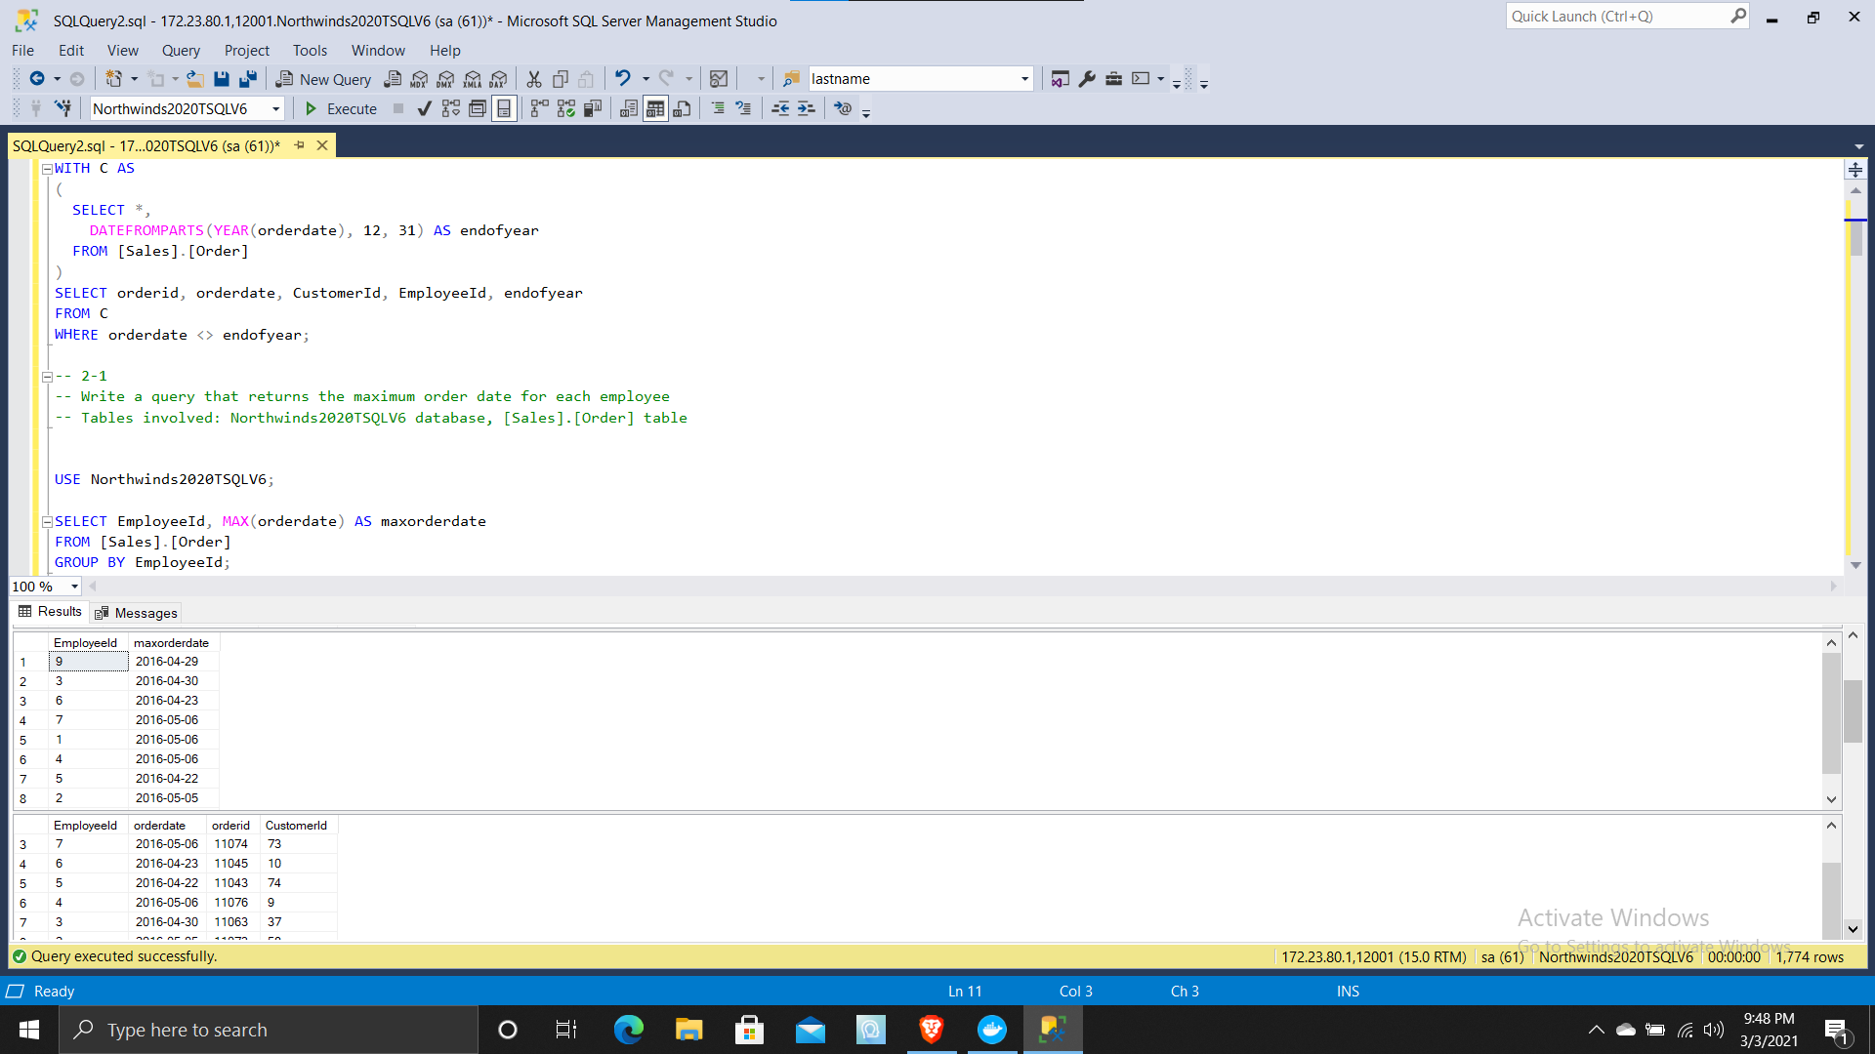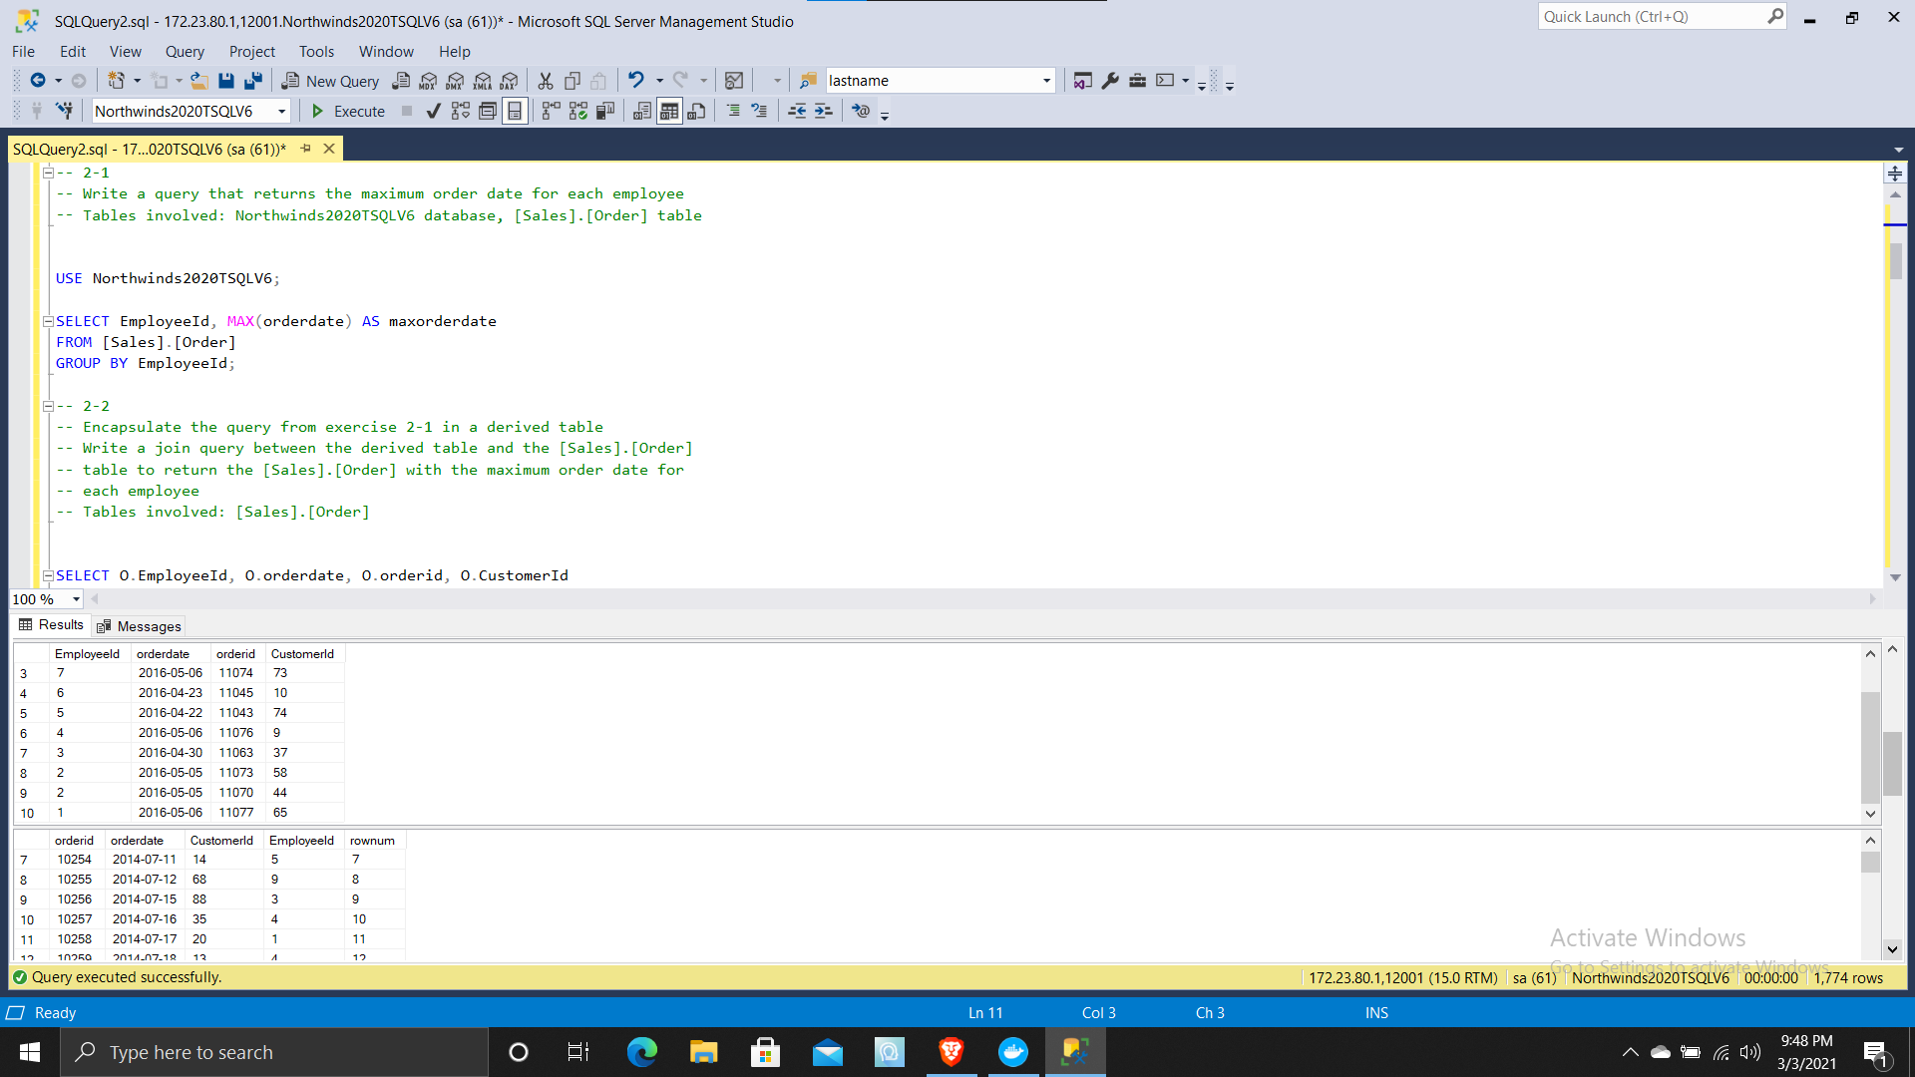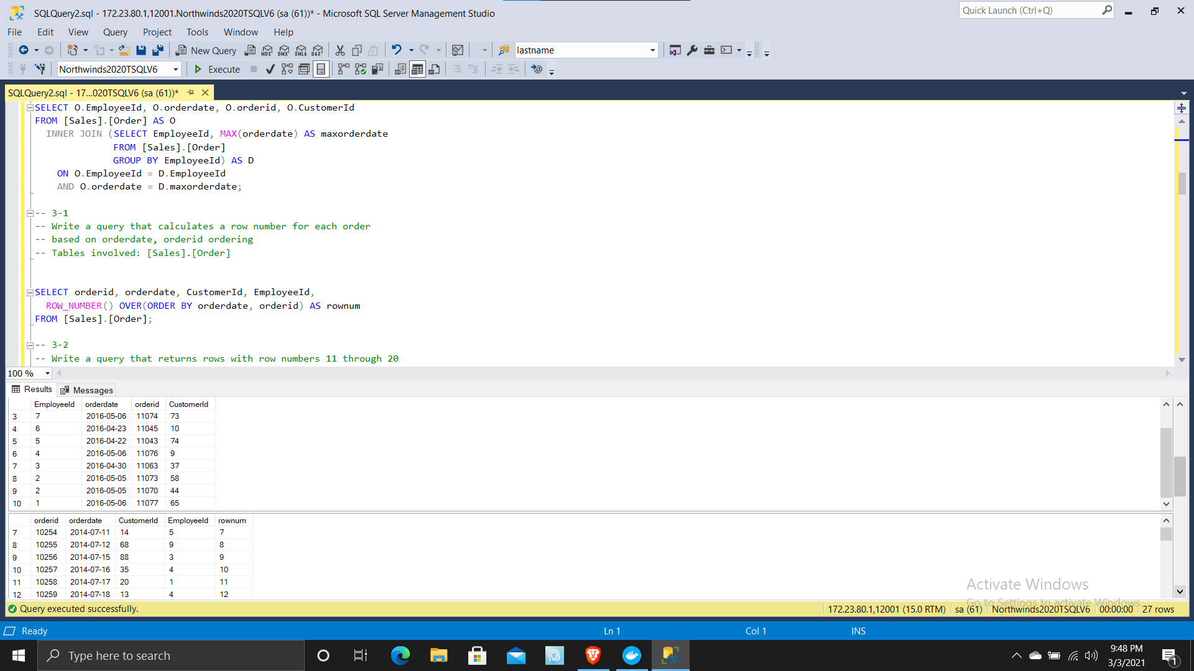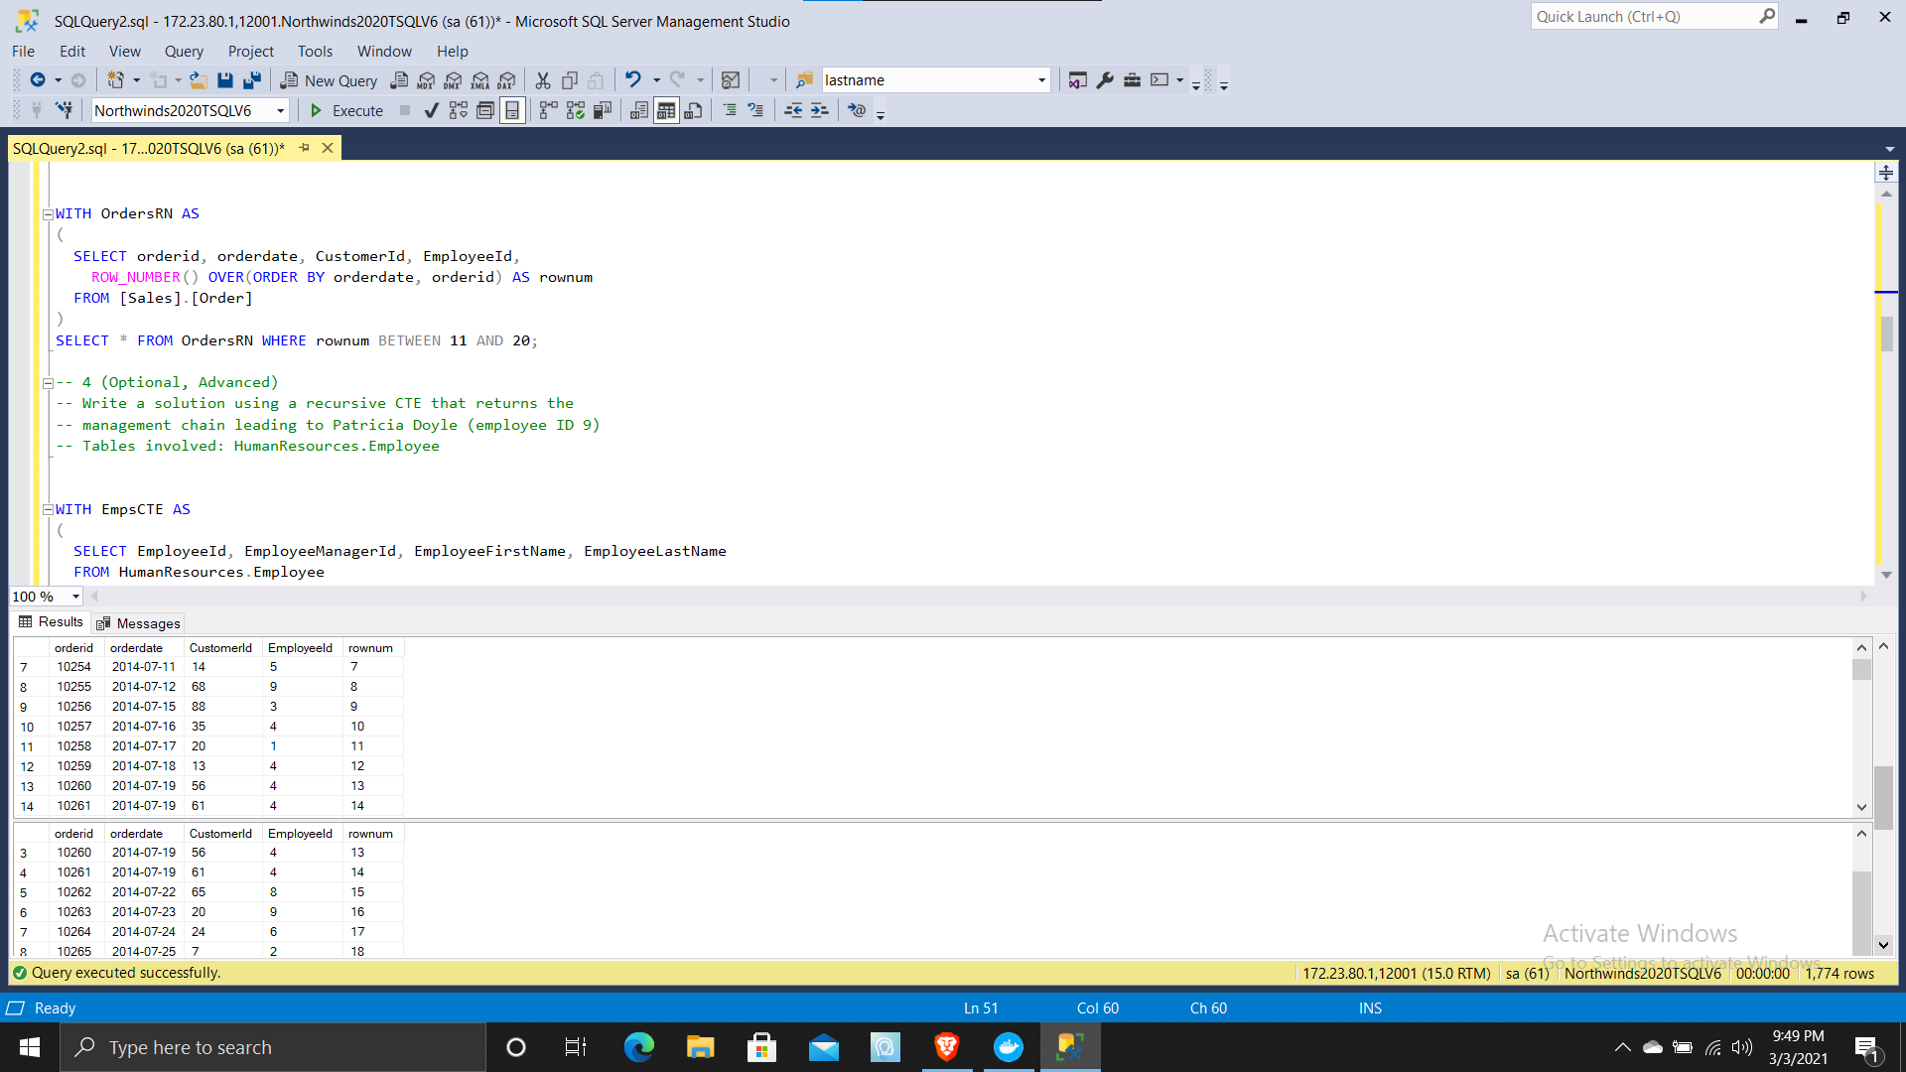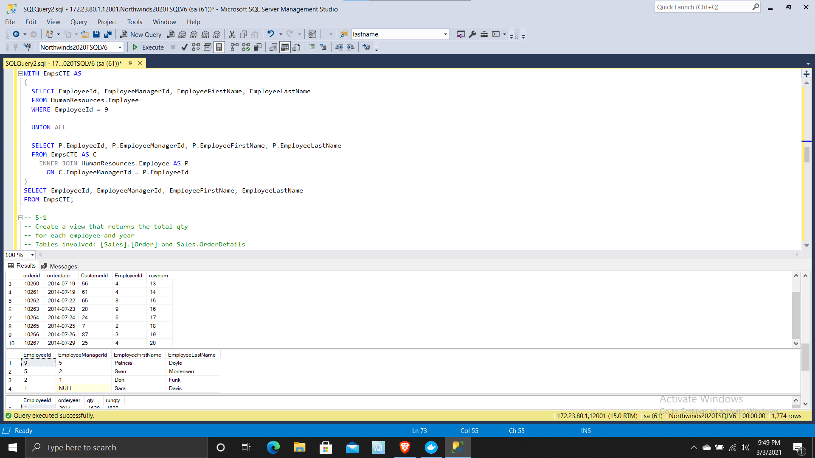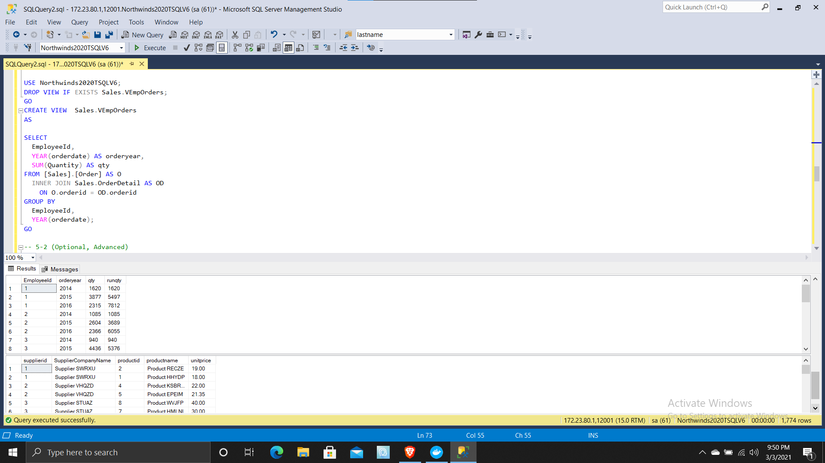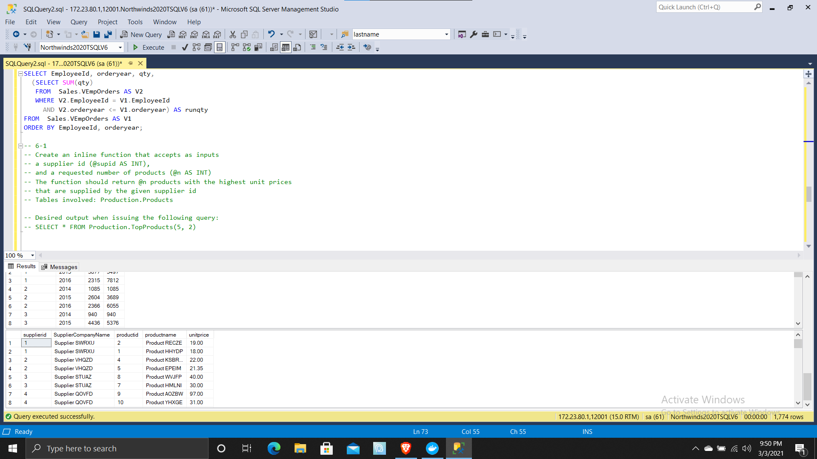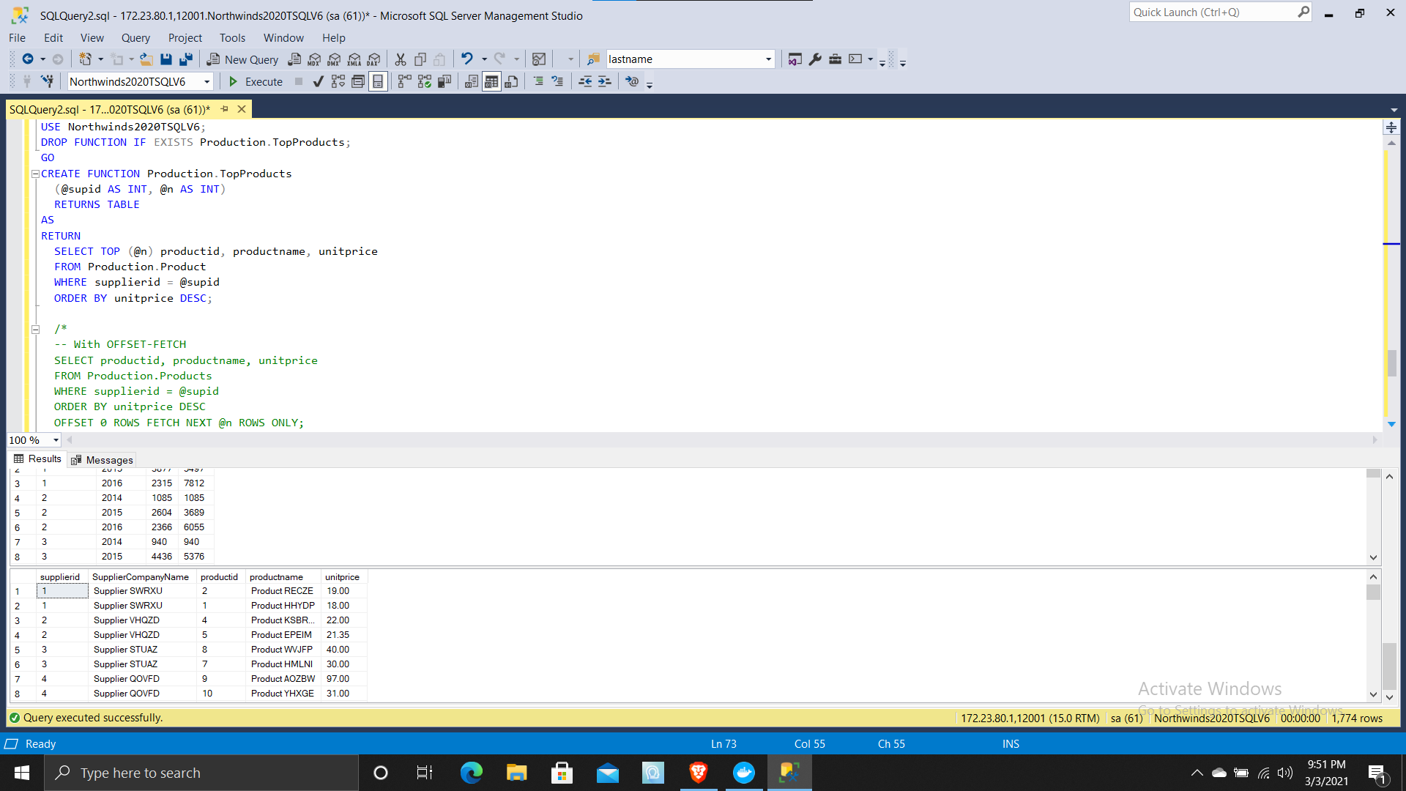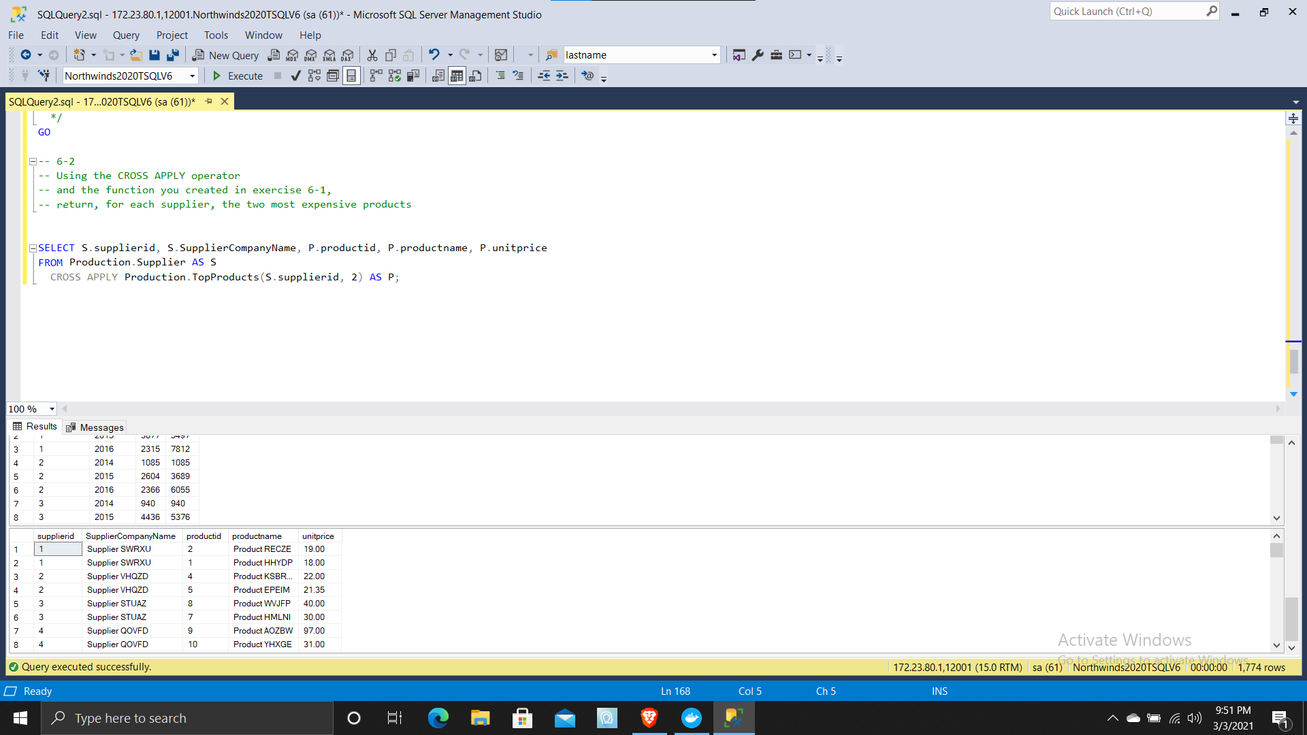

(828 rows affected)

(9 rows affected)

(10 rows affected)

(831 rows affected)

(10 rows affected)

(4 rows affected)

(27 rows affected)

(55 rows affected)

Completion time: 2021-03-03T22:04:50.6902194-05:00